**VISVESVARAYA TECHNOLOGICAL UNIVERSITY**

**“JnanaSangama”, Belgaum -590014, Karnataka.**



**LAB REPORT**

**on**

**Object Oriented Java Programming**

**(23CS3PCOOJ)**

***Submitted by***

**Aksha S (1BM23CS019)**

***in partial fulfillment for the award of the degree of***

**BACHELOR OF ENGINEERING**

***in***

**COMPUTER SCIENCE AND ENGINEERING**



**B.M.S. COLLEGE OF ENGINEERING**

**(Autonomous Institution under VTU)**

**BENGALURU-560019**

**Sep-2024 to Jan-2025**

**B.M.S. College of Engineering,**

**Bull Temple Road, Bangalore 560019**

(Affiliated To Visvesvaraya Technological University, Belgaum)

**DepartmentofComputerScienceandEngineering**

**CERTIFICATE**

This is to certify that the Lab work entitled “Object Oriented Java Programming (23CS3PCOOJ)” carried out by **Aksha S (1BM23CS019),** who is bonafide student of **B.M.S. College of Engineering.** It is in partial fulfillment for the award of **Bachelor of Engineering in Computer Science and Engineering** of the Visvesvaraya Technological University, Belgaum. The Lab report has been approved as it satisfies the academic requirements in respect of an Object Oriented Java Programming (23CS3PCOOJ) work prescribed for the said degree.

|  |  |
| --- | --- |
| Lab faculty Incharge Name  Assistant Professor  Department of CSE, BMSCE | Dr. Jyothi S Nayak  Professor & HOD  Department of CSE, BMSCE |

**)**

**Index**

|  |  |  |  |
| --- | --- | --- | --- |
| **Sl.**  **No.** | **Date** | **Experiment Title** | **Page No.** |
| 1 | 9/10/24 | Implement Quadratic Equation | 4 |
| 2 | 16/10/24 | Implement SGPA Calculator | 6 |
| 3 | 23/10/24 | Create Objects for Books | 12 |
| 4 | 23/10/24 | Implement Abstract Class | 17 |
| 5 | 13/11/24 | Bank Account Management | 22 |
| 6 | 13/11/24 | Implement Packages | 32 |
| 7 | 20/11/24 | Implement Exception Handling | 39 |
| 8 | 27/11/24 | Multithreading, Creating Threads in Java | 44 |
| 9 | 27/11/24 | Interface to Perform Integer Division | 48 |
| 10 | 27/11/24 | Implement Deadlock  Implement Inter-process Communication | 53 |

Github Link: <https://github.com/akshas-25/OOJ-LAB>

**Program 1**

Implement Quadratic Equation

Algorithm:

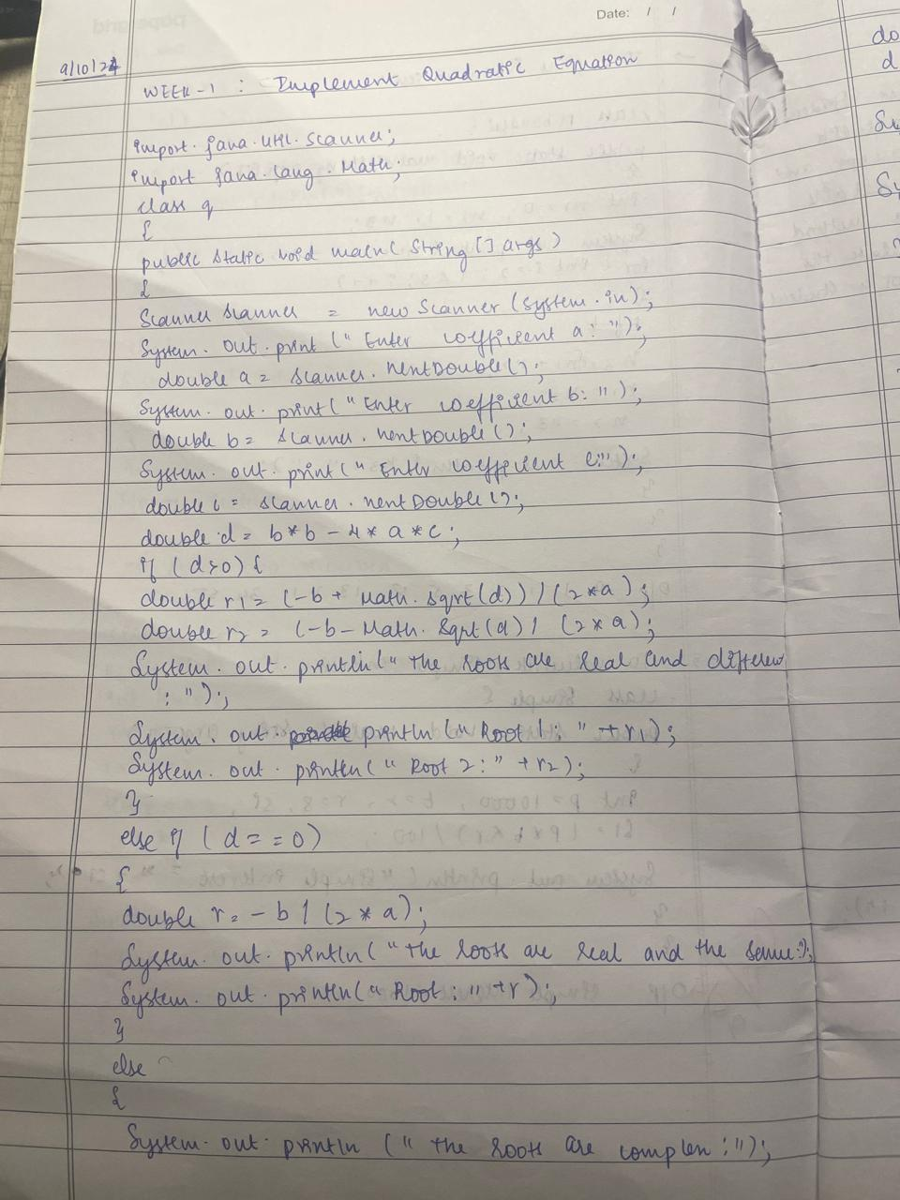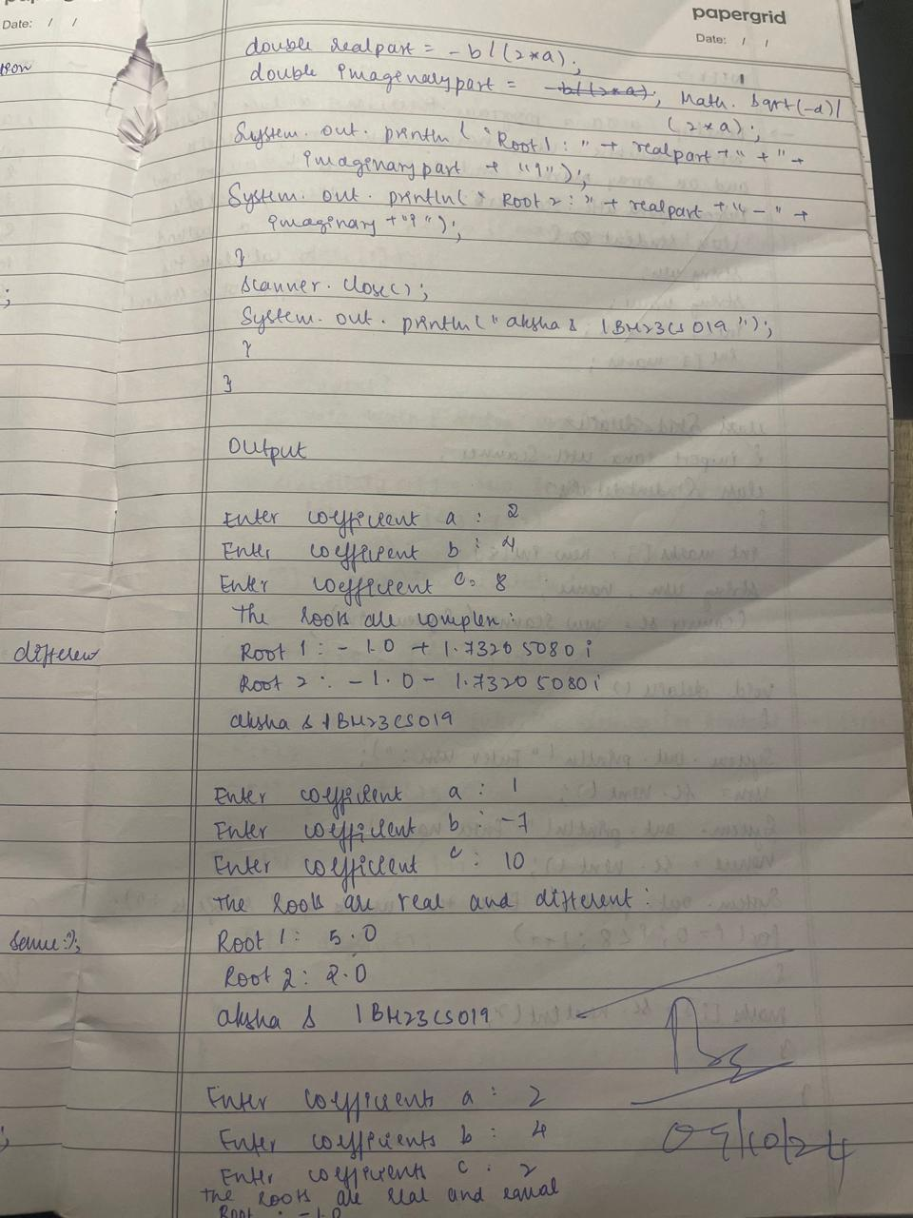

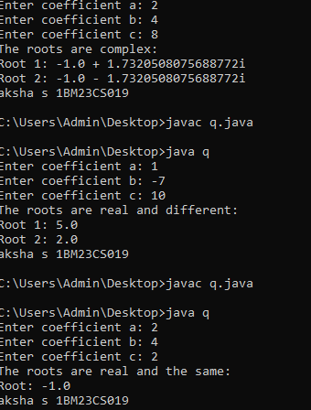

Code:

import java.util.Scanner;

import java.lang.Math;

class q {

public static void main(String[] args) {

Scanner scanner = new Scanner(System.in);

System.out.print("Enter coefficient a: ");

double a = scanner.nextDouble();

System.out.print("Enter coefficient b: ");

double b = scanner.nextDouble();

System.out.print("Enter coefficient c: ");

double c = scanner.nextDouble();

double d = b * b - 4 * a * c;

if (d > 0) {

double r1 = (-b + Math.sqrt(d)) / (2 * a);

double r2 = (-b - Math.sqrt(d)) / (2 * a);

System.out.println("The roots are real and different:");

System.out.println("Root 1: " + r1);

System.out.println("Root 2: " + r2);

} else if (d == 0) {

double r = -b / (2 * a);

System.out.println("The roots are real and the same:");

System.out.println("Root: " + r);

} else {

System.out.println("The roots are complex:");

double realPart = -b / (2 * a);

double imaginaryPart = Math.sqrt(-d) / (2 * a);

System.out.println("Root 1: " + realPart + " + " + imaginaryPart + "i");

System.out.println("Root 2: " + realPart + " - " + imaginaryPart + "i");

}

scanner.close();

System.out.println("aksha s 1BM23CS019");

}

}

Program 2:

Develop a Java program to create a class Student with members usn,

name, an array credits and an array marks. Include methods to accept and display details and a method to calculate SGPA of a student

Algorithm:

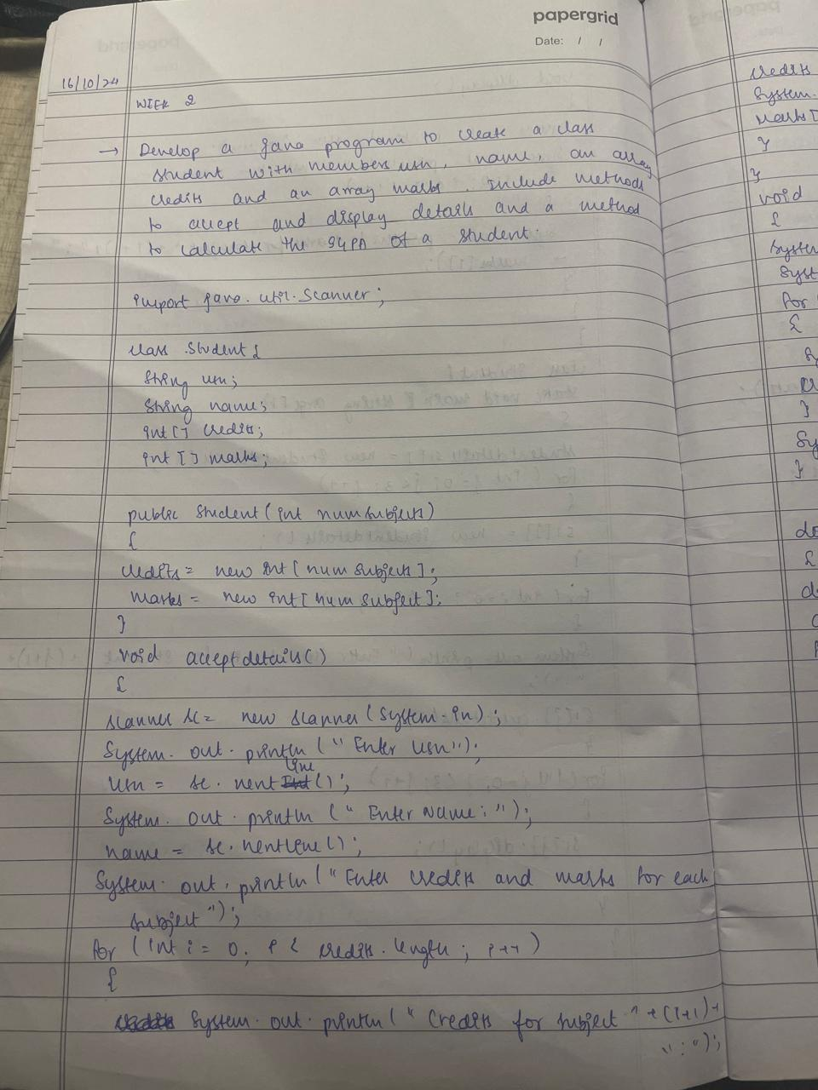

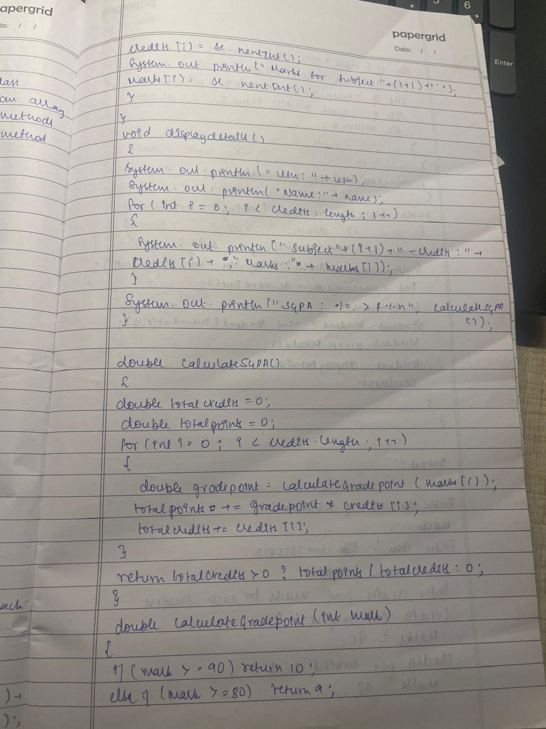

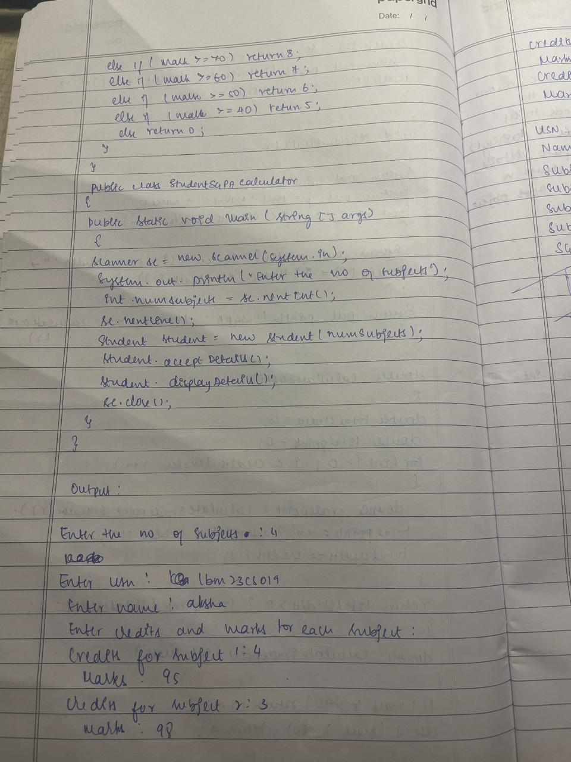

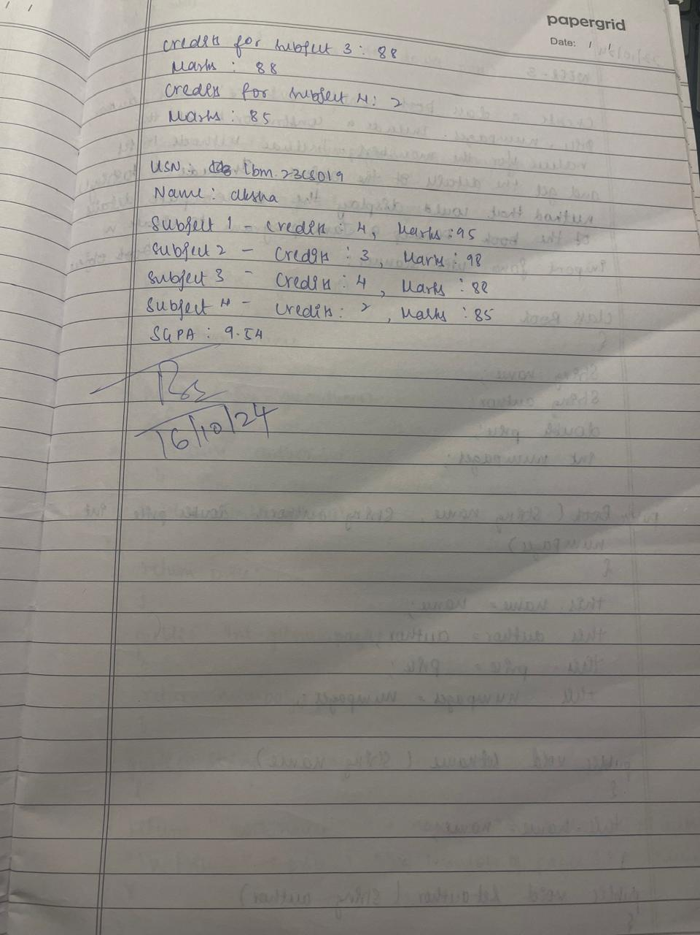

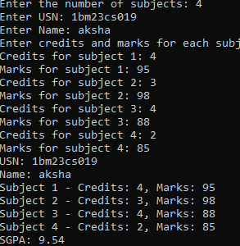

Code:

import java.util.Scanner;

class Student {

String usn;

String name;

int[] credits;

int[] marks;

public Student(int numSubjects) {

credits = new int[numSubjects];

marks = new int[numSubjects];

}

void acceptDetails() {

Scanner sc = new Scanner(System.in);

System.out.print("Enter USN: ");

usn = sc.nextLine(); // Using nextLine to capture full input

System.out.print("Enter Name: ");

name = sc.nextLine(); // Using nextLine to capture full input

System.out.println("Enter credits and marks for each subject:");

for (int i = 0; i < credits.length; i++) {

System.out.print("Credits for subject " + (i + 1) + ": ");

credits[i] = sc.nextInt();

System.out.print("Marks for subject " + (i + 1) + ": ");

marks[i] = sc.nextInt();

}

}

void displayDetails() {

System.out.println("USN: " + usn);

System.out.println("Name: " + name);

for (int i = 0; i < credits.length; i++) {

System.out.println("Subject " + (i + 1) + " - Credits: " + credits[i] + ", Marks: " + marks[i]);

}

System.out.printf("SGPA: %.2f%n", calculateSGPA());

}

double calculateSGPA() {

double totalCredits = 0;

double totalPoints = 0;

for (int i = 0; i < credits.length; i++) {

double gradePoint = calculateGradePoint(marks[i]);

totalPoints += gradePoint * credits[i];

totalCredits += credits[i];

}

return totalCredits > 0 ? totalPoints / totalCredits : 0;

}

double calculateGradePoint(int mark) {

if (mark >= 90) return 10;

else if (mark >= 80) return 9;

else if (mark >= 70) return 8;

else if (mark >= 60) return 7;

else if (mark >= 50) return 6;

else if (mark >= 40) return 5;

else return 0; // Fail

}

}

public class StudentSGPACalculator {

public static void main(String[] args) {

Scanner sc = new Scanner(System.in);

System.out.print("Enter the number of subjects: ");

int numSubjects = sc.nextInt();

sc.nextLine();

Student student = new Student(numSubjects);

student.acceptDetails();

student.displayDetails();

sc.close();

}

}

Program 3:

Create a class Book which contains four members: name, author,

price, num_pages. Include a constructor to set the values for the

members. Include methods to set and get the details of the objects.

Include a toString( ) method that could display the complete details of

the book. Develop a Java program to create n book objects.

Algorithm:

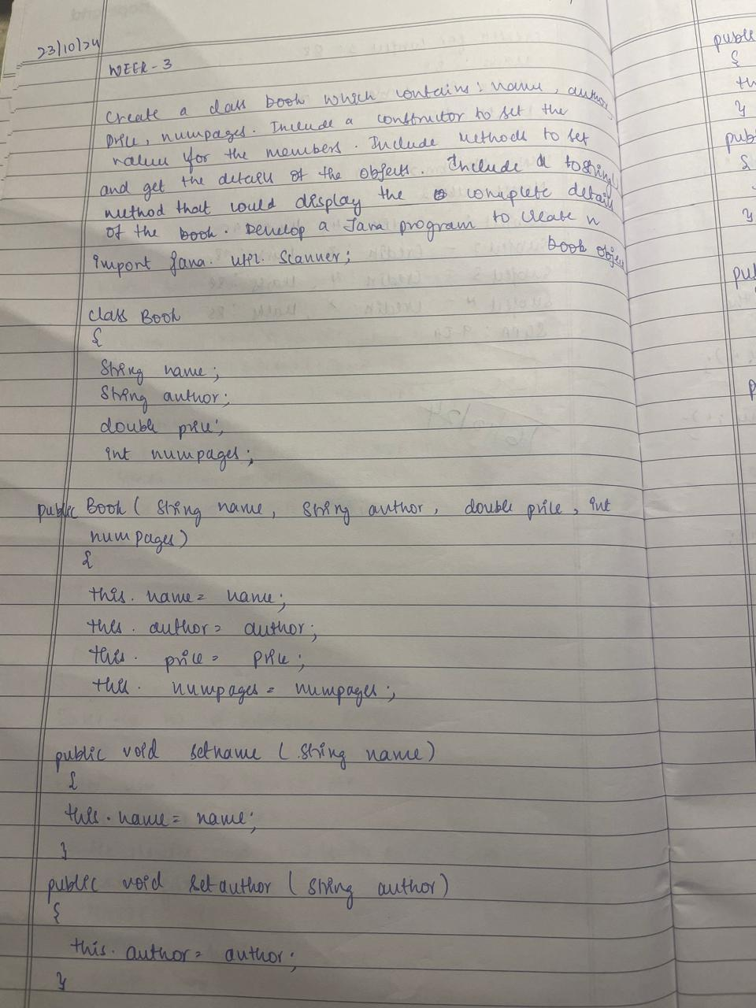

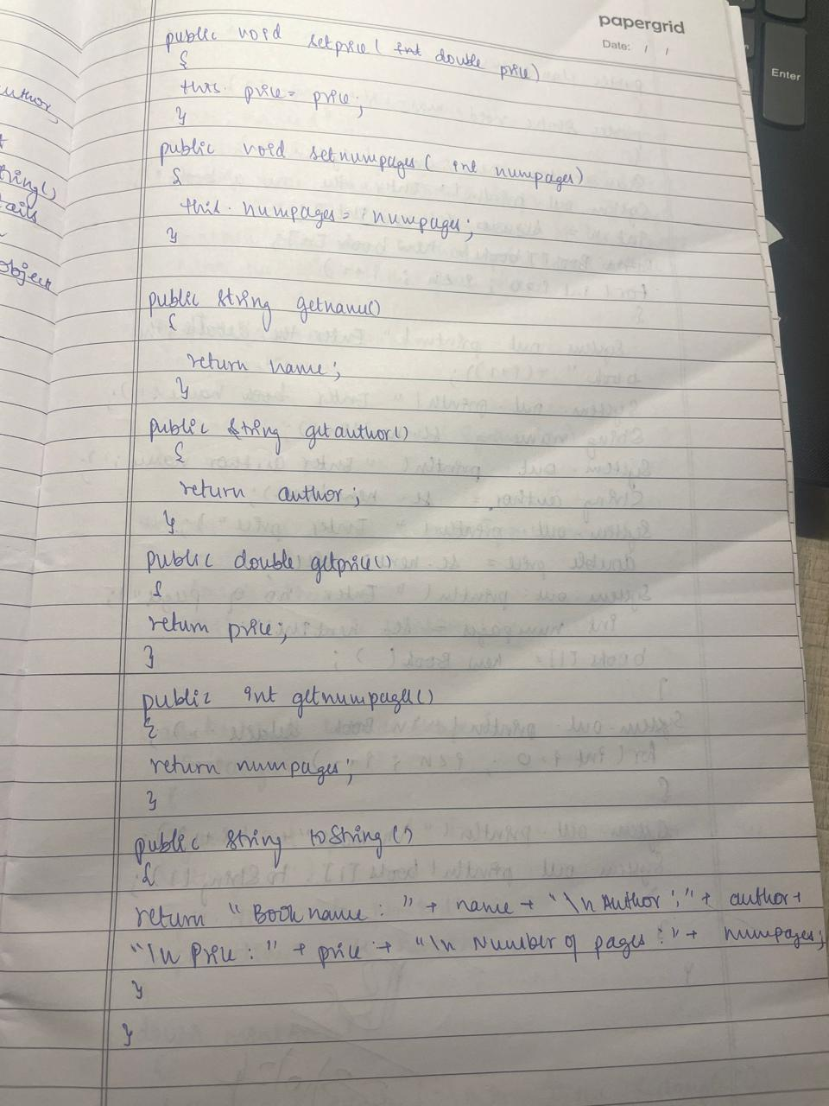

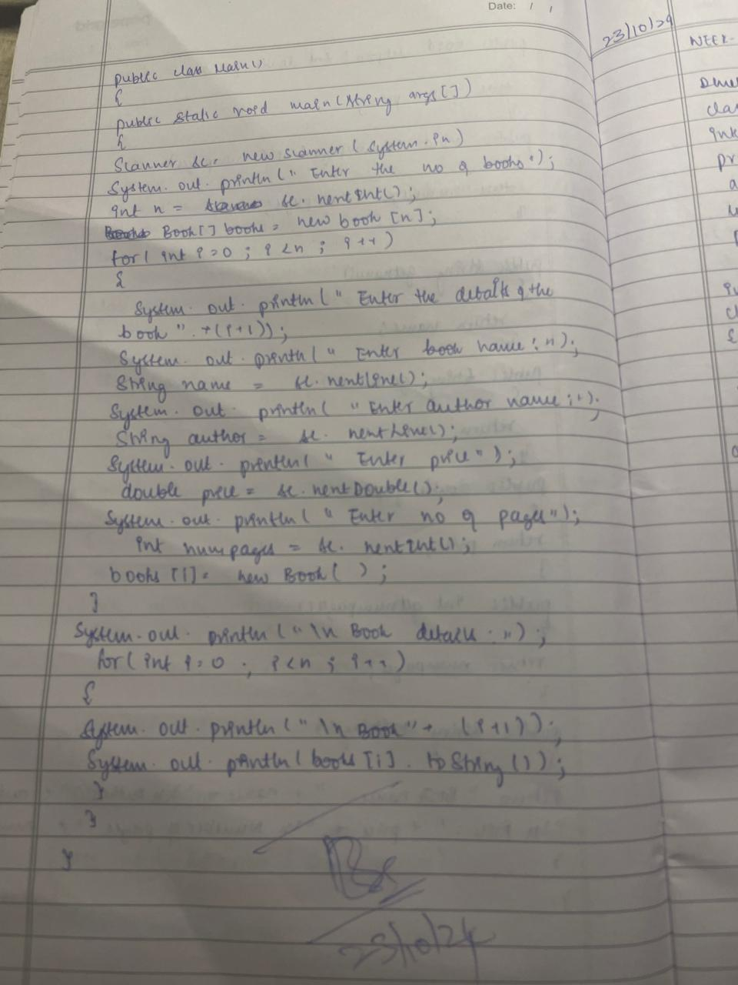

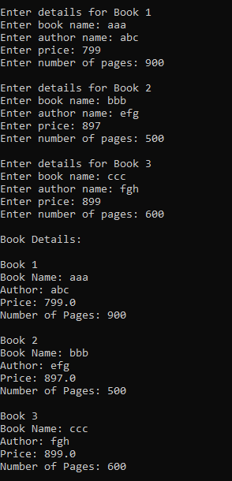

Code:

import java.util.Scanner;

class Book {

private String name;

private String author;

private double price;

private int numPages;

public Book(String name, String author, double price, int numPages) {

this.name = name;

this.author = author;

this.price = price;

this.numPages = numPages;

}

public void setName(String name) {

this.name = name;

}

public void setAuthor(String author) {

this.author = author;

}

public void setPrice(double price) {

this.price = price;

}

public void setNumPages(int numPages) {

this.numPages = numPages;

}

public String getName() {

return name;

}

public String getAuthor() {

return author;

}

public double getPrice() {

return price;

}

public int getNumPages() {

return numPages;

}

public String toString() {

return "Book Name: " + name + "\nAuthor: " + author + "\nPrice: " + price + "\nNumber of Pages: " + numPages;

}

}

public class Main {

public static void main(String[] args) {

Scanner sc = new Scanner(System.in);

System.out.print("Enter the number of books: ");

int n = sc.nextInt();

sc.nextLine();

Book[] books = new Book[n];

for (int i = 0; i < n; i++) {

System.out.println("\nEnter details for Book " + (i + 1));

System.out.print("Enter book name: ");

String name = sc.nextLine();

System.out.print("Enter author name: ");

String author = sc.nextLine();

System.out.print("Enter price: ");

double price = sc.nextDouble();

System.out.print("Enter number of pages: ");

int numPages = sc.nextInt();

sc.nextLine();

books[i] = new Book(name, author, price, numPages);

}

System.out.println("\nBook Details:");

for (int i = 0; i < n; i++) {

System.out.println("\nBook " + (i + 1));

System.out.println(books[i].toString());

}

}}

Program 4:

Develop a Java program to create an abstract class

named Shape that contains two integers and an

empty method named printArea( ). Provide three

classes named Rectangle, Triangle and Circle such

that each one of the classes extends the class

Shape. Each one of the classes contain only the

method printArea( ) that prints the area of the given

shape.

Algorithm:

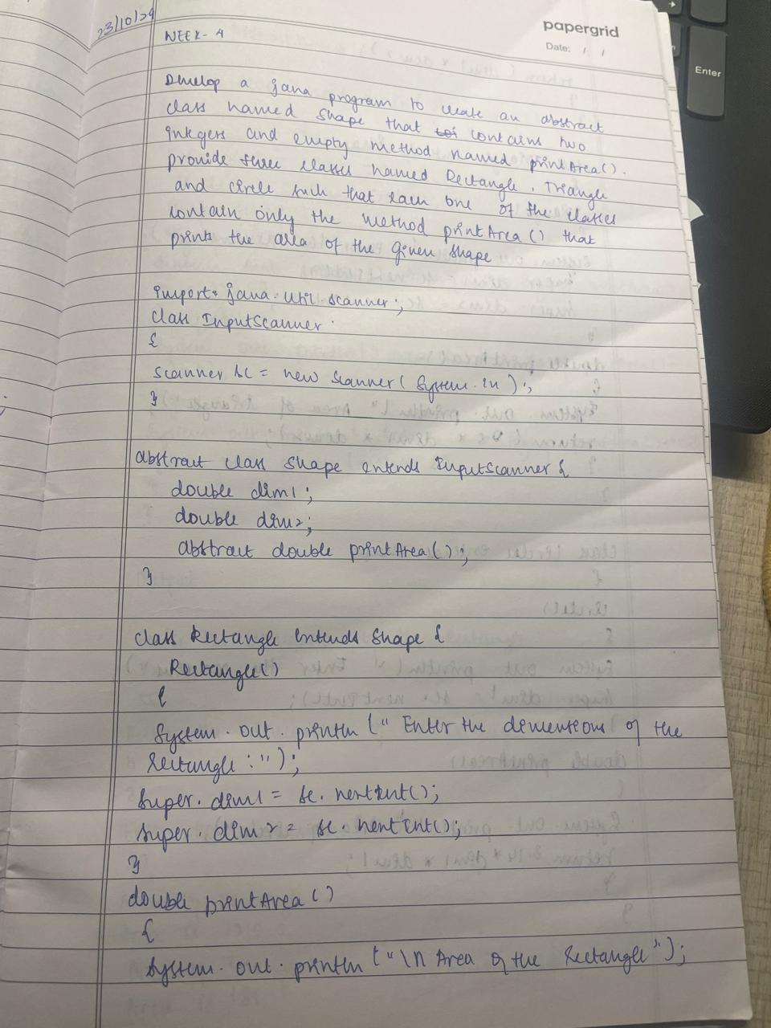

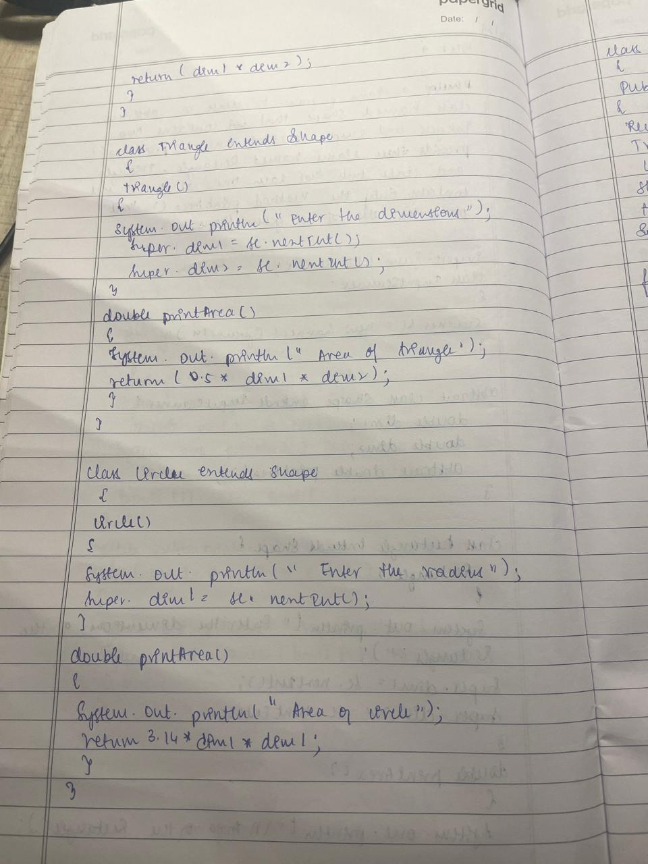

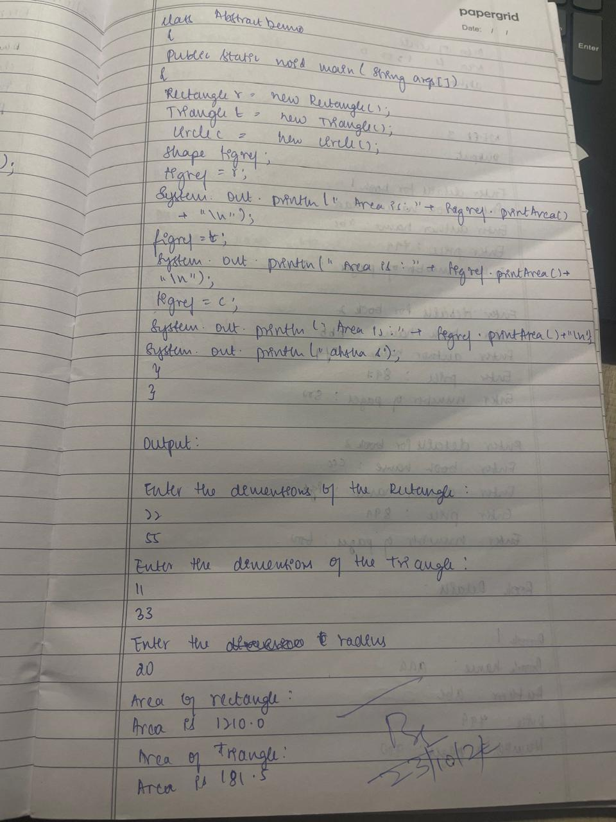

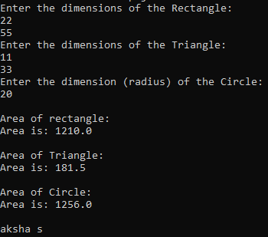

Code:

import java.util.Scanner;

class InputScanner{

Scanner sc = new Scanner(System.in);

}

abstract class Shape extends InputScanner{

double dim1;

double dim2;

abstract double printArea();

}

class Rectangle extends Shape{

Rectangle(){

System.out.println("Enter the dimensions of the Rectangle: ");

super.dim1 = sc.nextInt();

super.dim2 = sc.nextInt();

}

double printArea(){

System.out.println("\nArea of rectangle: ");

return(dim1 * dim2);

}

}

class Triangle extends Shape{

Triangle (){

System.out.println("Enter the dimensions of the Triangle: ");

super.dim1 = sc.nextInt();

super.dim2 = sc.nextInt();

}

double printArea(){

System.out.println("Area of Triangle: ");

return 0.5 * dim1 * dim2;

}

}

class Circle extends Shape{

Circle (){

System.out.println("Enter the dimension (radius) of the Circle: ");

super.dim1 = sc.nextInt();

}

double printArea(){

System.out.println("Area of Circle: ");

return 3.14*dim1*dim1;

}

}

class AbstractDemo{

public static void main(String args[]){

Rectangle r = new Rectangle();

Triangle t = new Triangle();

Circle c = new Circle ();

Shape figref;

figref = r;

System.out.println("Area is: "+figref.printArea()+"\n");

figref = t;

System.out.println("Area is: "+ figref.printArea()+"\n");

figref = c;

System.out.println("Area is: "+figref.printArea()+"\n");

System.out.println("aksha s");

}

}

Program 5:

Create a class Account that stores customer name, account number and

type of account. From this derive the classes Cur-acct and Sav-acct to

make them more specific to their requirements. Include

the necessary methods in order to achieve the following tasks:

a)Accept deposit from customer and update the balance.

b)Display the balance.

c)Compute and deposit interest

d)Permit withdrawal and update the balance

e) Check for the minimum balance, impose penalty if necessary and

update the balance.

Algorithm:

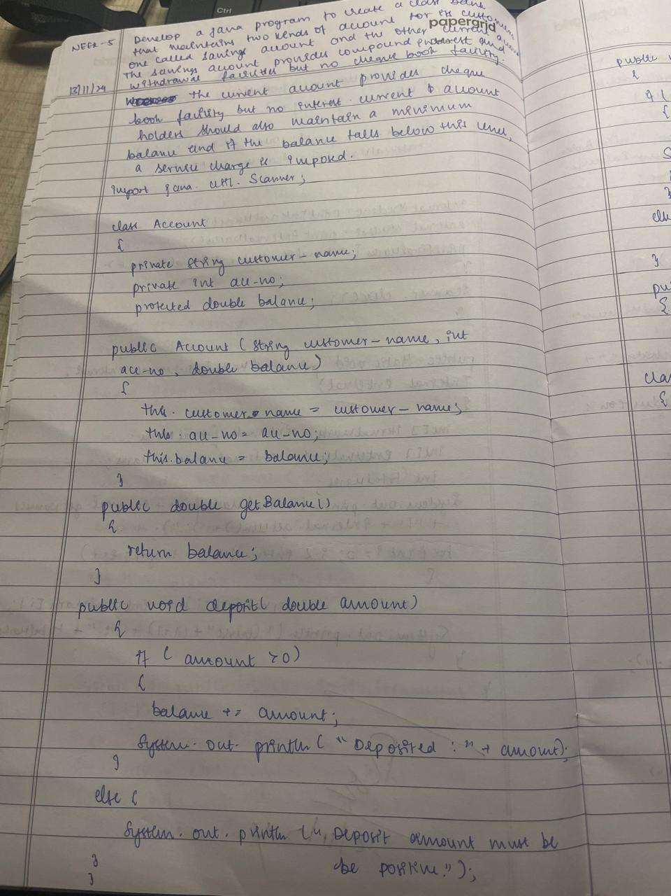

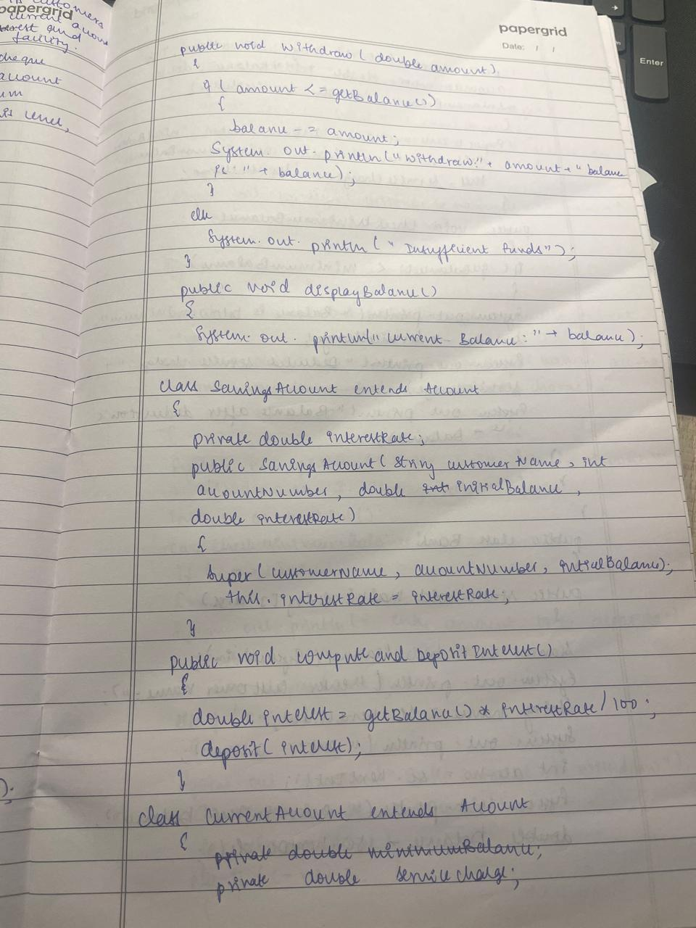

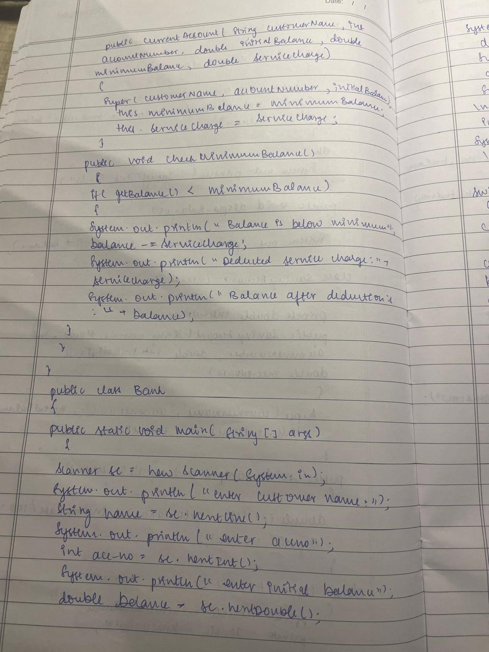

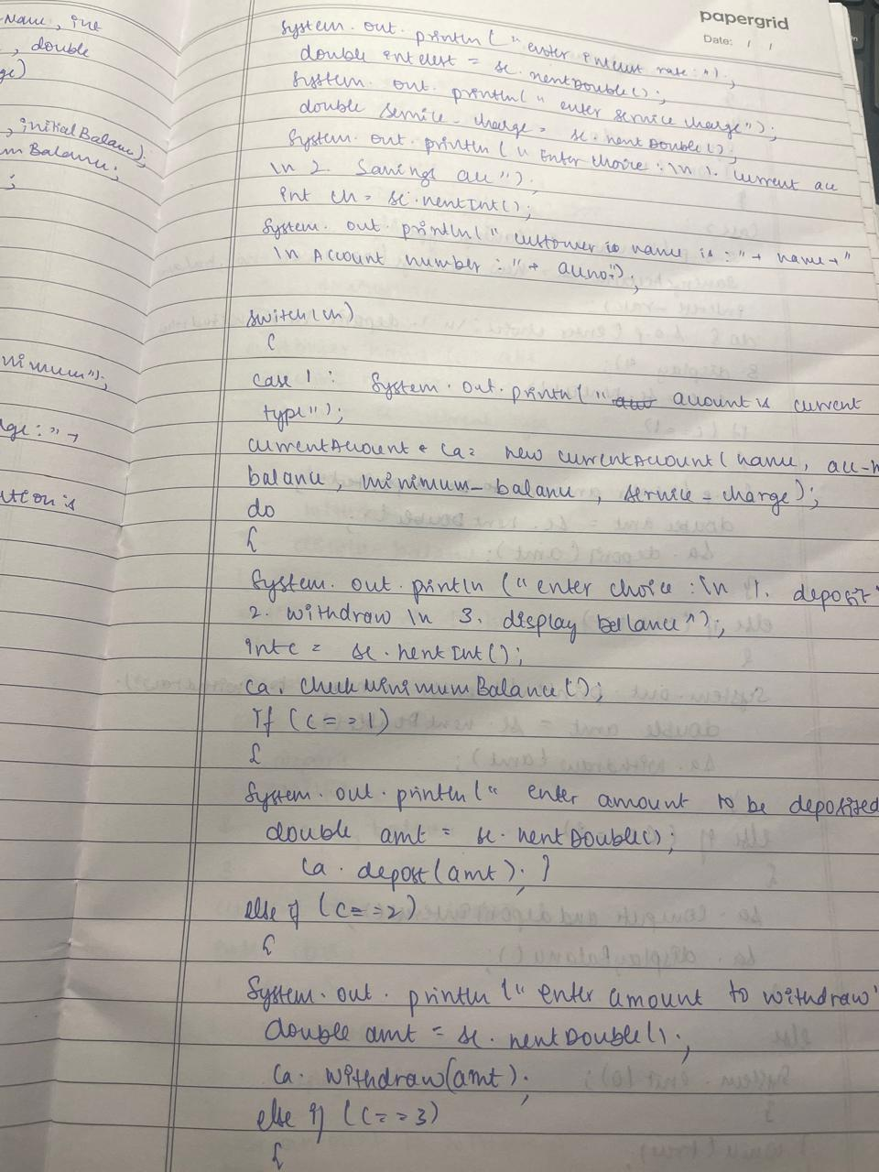

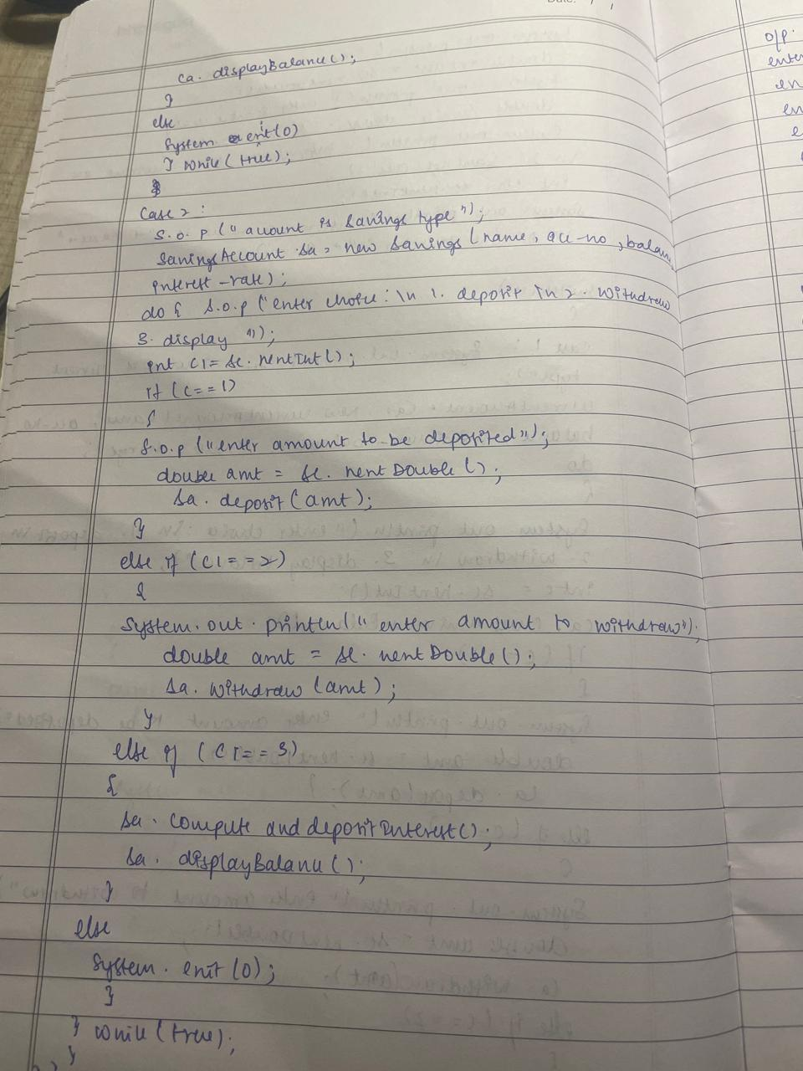

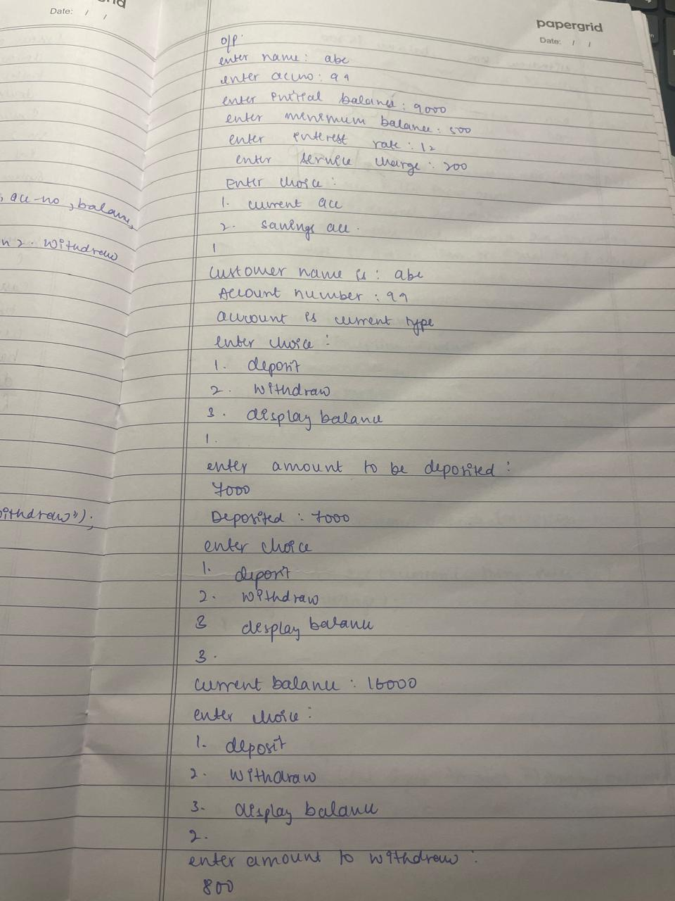

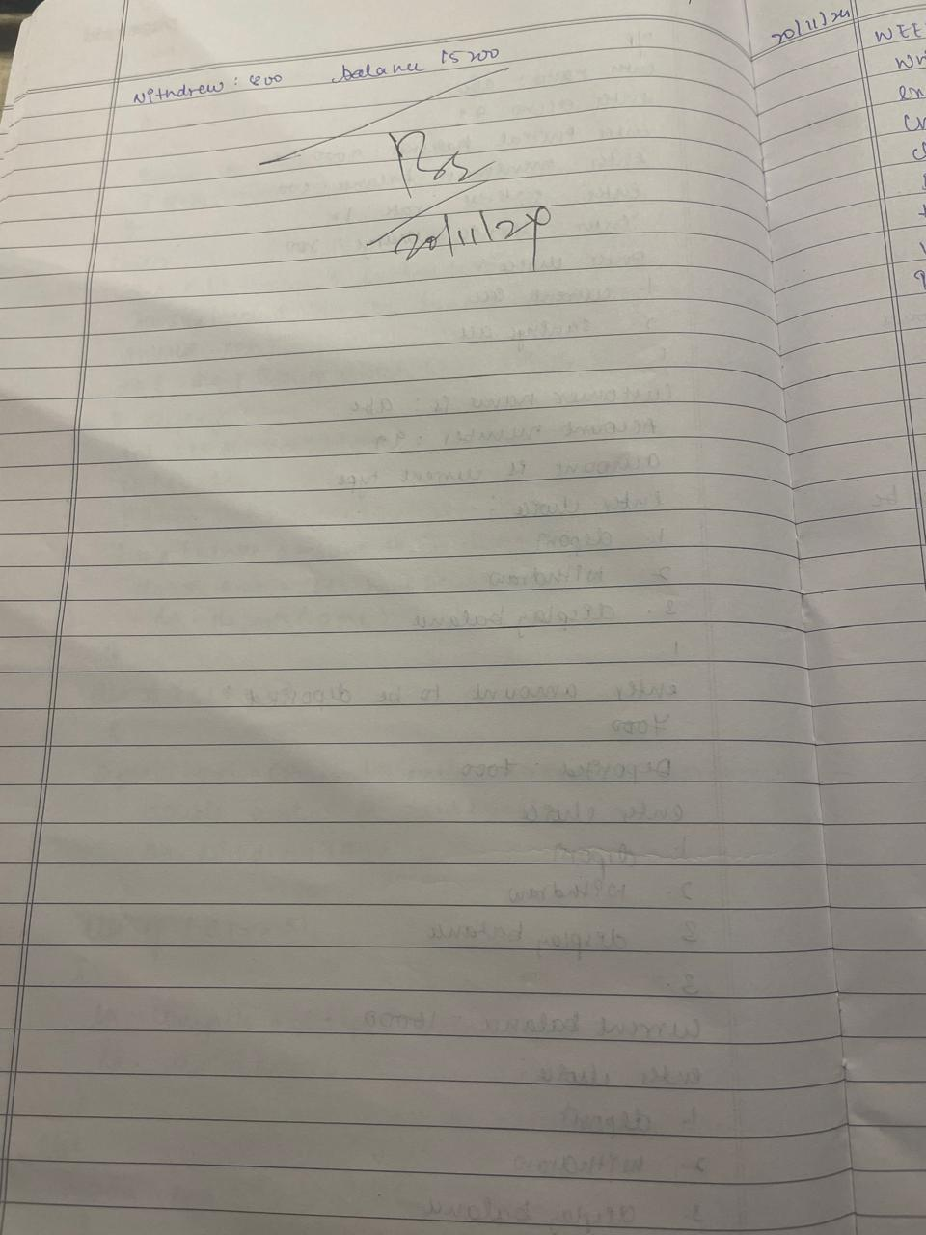

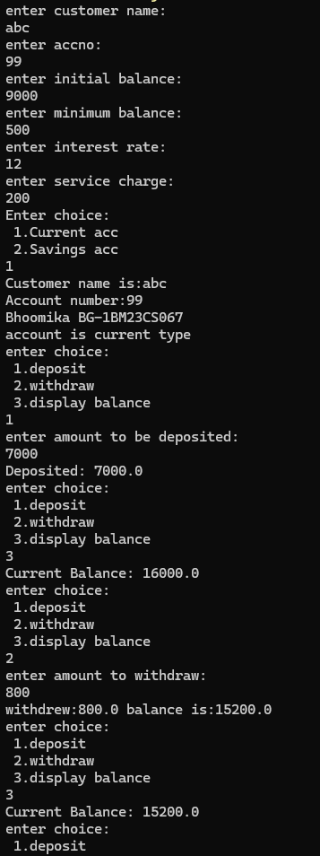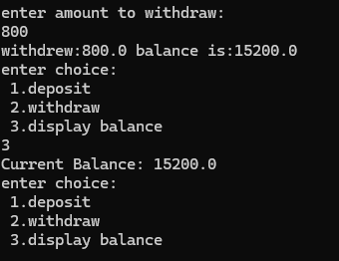

Code:

import java.util.Scanner;

class Account {

private String customer_name;

private int acc_no;

protected double balance;

public Account(String customer_name, int acc_no, double balance) {

this.customer_name = customer_name;

this.acc_no = acc_no;

this.balance = balance;

}

public double getBalance() {

return balance;

}

public void deposit(double amount) {

if (amount > 0) {

balance += amount;

System.out.println("Deposited: " + amount);

} else {

System.out.println("Deposit amount must be positive.");

}

}

public void withdraw(double amount)

{

if(amount<=getBalance()){

balance-=amount;

System.out.println("withdrew:"+amount + " balance is:"+ balance);

}

else

System.out.println("Insufficient funds!!");

}

public void displayBalance(){

System.out.println("Current Balance: " + balance);

}

}

class SavingsAccount extends Account {

private double interestRate;

public SavingsAccount(String customerName, int accountNumber, double initialBalance, double interestRate) {

super(customerName, accountNumber, initialBalance);

this.interestRate = interestRate;

}

public void computeAndDepositInterest() {

double interest = getBalance() * interestRate / 100;

deposit(interest);

}

}

class CurrentAccount extends Account {

private double minimumBalance;

private double serviceCharge;

public CurrentAccount(String customerName, int accountNumber, double initialBalance, double minimumBalance, double serviceCharge) {

super(customerName, accountNumber, initialBalance);

this.minimumBalance = minimumBalance;

this.serviceCharge = serviceCharge;

}

public void checkMinimumBalance() {

if (getBalance() < minimumBalance) {

System.out.println("Balance is below minimum");

balance-=serviceCharge;

System.out.println("Deducted service charge:" +serviceCharge);

System.out.println("Balance after deduction is:"+balance);

}

}

}

public class Bank {

public static void main(String[] args) {

Scanner sc = new Scanner(System.in);

System.out.println("enter customer name:");

String name=sc.nextLine();

System.out.println("enter accno:");

int acc_no=sc.nextInt();

System.out.println("enter initial balance:");

double balance=sc.nextDouble();

System.out.println("enter minimum balance:");

double minimum_balance=sc.nextDouble();

System.out.println("enter interest rate:");

double interest_rate=sc.nextDouble();

System.out.println("enter service charge:");

double service_charge=sc.nextDouble();

System.out.println("Enter choice:\n 1.Current acc\n 2.Savings acc");

int ch=sc.nextInt();

System.out.println("Customer name is:"+ name+"\nAccount number:"+acc_no+");

switch(ch){

case(1):

System.out.println("account is current type");

CurrentAccount ca = new CurrentAccount(name,acc_no,balance,minimum_balance,service_charge);

do{ System.out.println("enter choice:\n 1.deposit\n 2.withdraw\n 3.display balance");

int c=sc.nextInt();

ca.checkMinimumBalance();

if(c==1){

System.out.println("enter amount to be deposited:");

double amt=sc.nextDouble();

ca.deposit(amt);}

else if(c==2){

System.out.println("enter amount to withdraw:");

double amt=sc.nextDouble();

ca.withdraw(amt);}

else if(c==3){

ca.displayBalance();}

else

System.exit(0);

}while(true);

case(2):

System.out.println("account is savings type");

SavingsAccount sa=new SavingsAccount(name,acc_no,balance,interest_rate);

do{ System.out.println("enter choice:\n 1.deposit\n 2.withdraw\n 3.display balance");

int c1=sc.nextInt();

if(c1==1){

System.out.println("enter amount to be deposited:");

double amt=sc.nextDouble();

sa.deposit(amt);}

else if(c1==2){

System.out.println("enter amount to withdraw:");

double amt=sc.nextDouble();

sa.withdraw(amt);}

else if(c1==3){

sa.computeAndDepositInterest();

sa.displayBalance();}

else{

System.exit(0);

}

}while(true);

}

}

}

Program 6:

Create a package CIE which has two classes- Student and Internals. The

classStudent has members like usn, name, sem. The class Internals

derived from Student has an array that stores the internal marks scored in

five courses of the current semester of the student. Create another

package SEE which has the class External which is a derived class of

Student. This class has an array that stores the SEE marks scored in five

courses of the current semester of the student. Import the two packages in

a file that declares the final marks of n students in all five courses.

Algorithm:

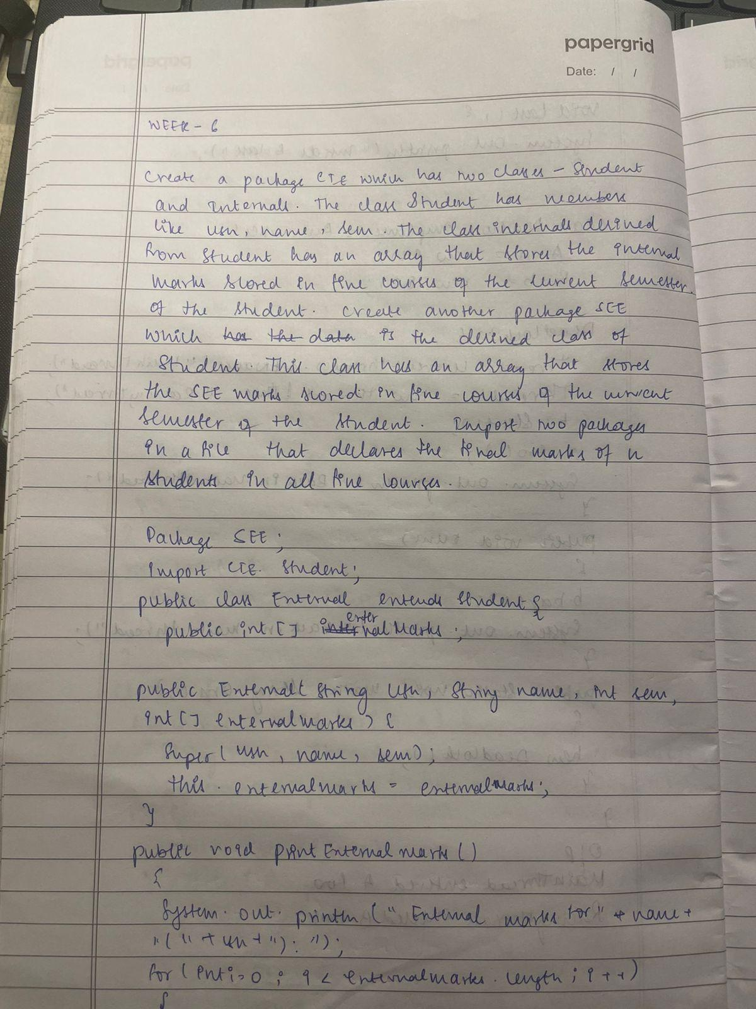

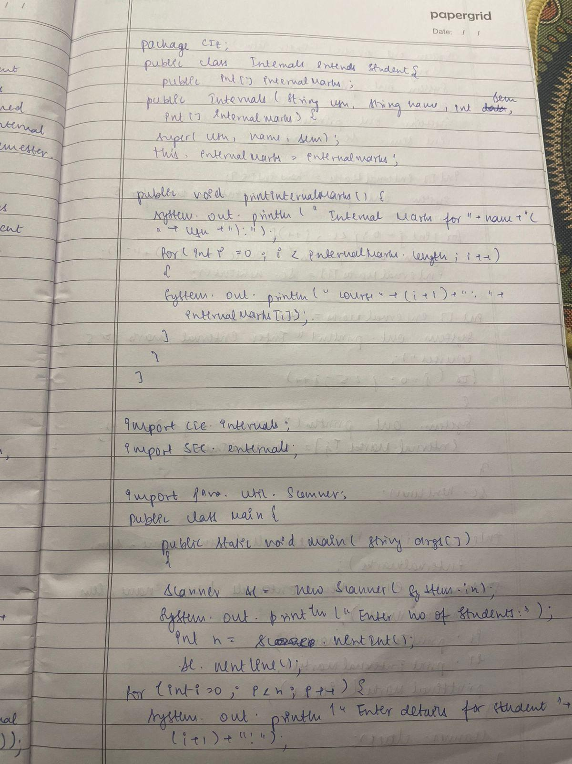

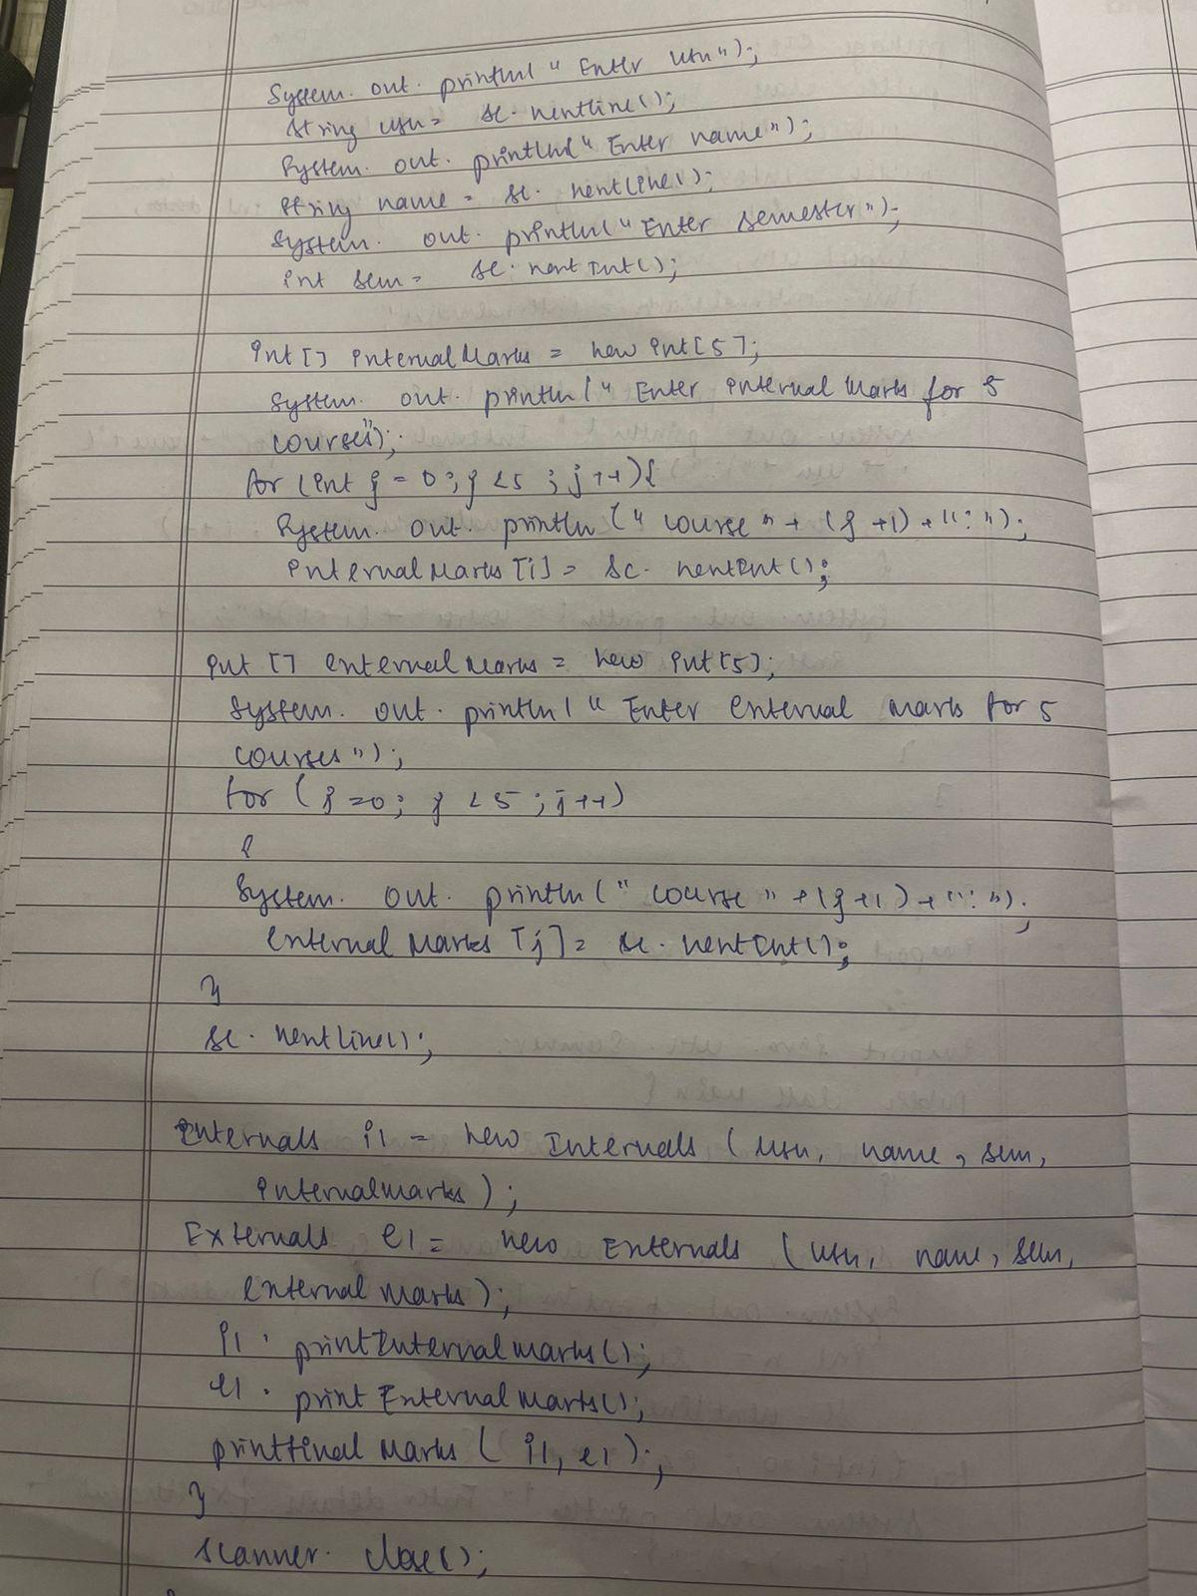

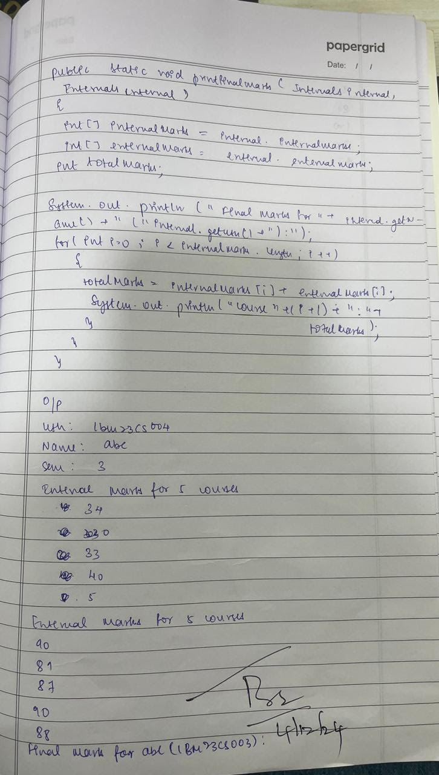

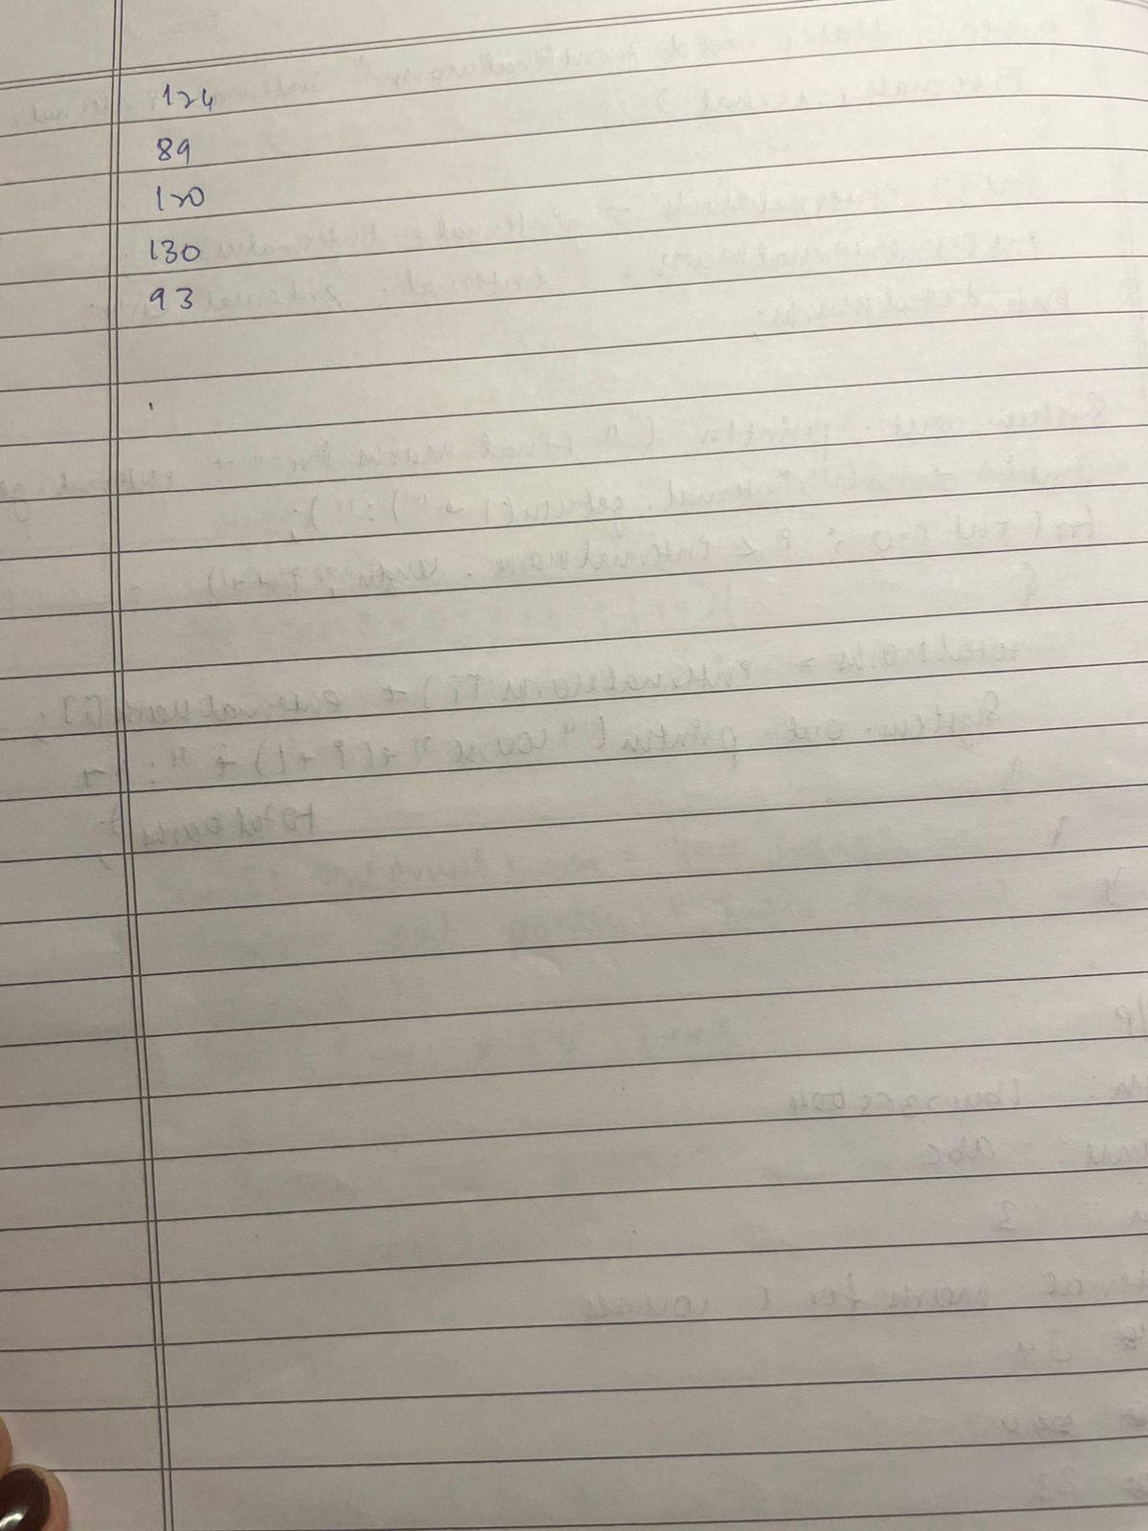

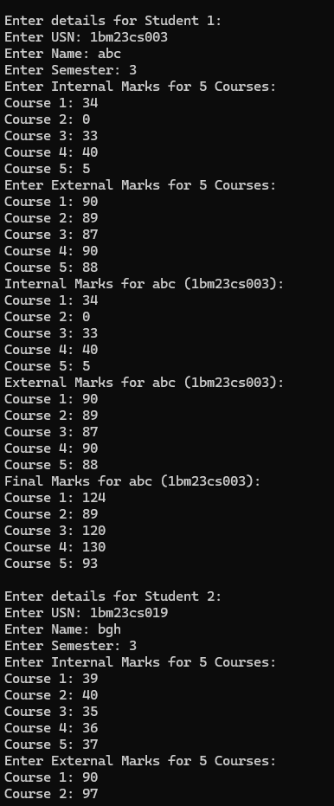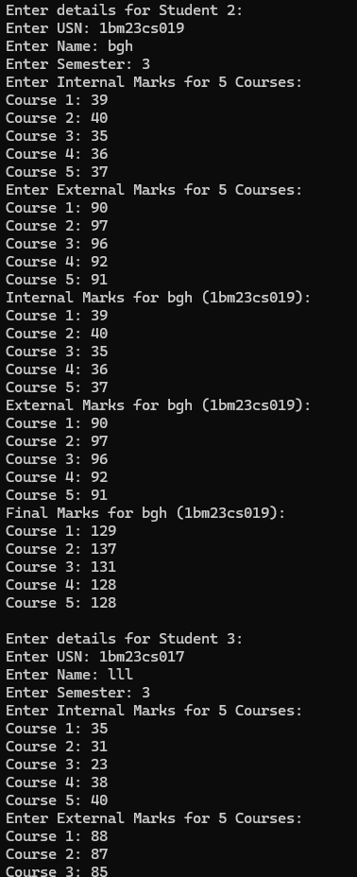

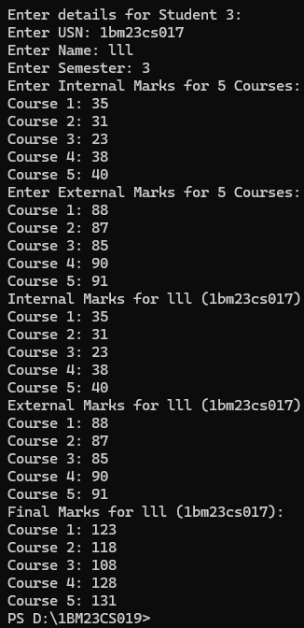

Code:

package SEE;

import CIE.Student;

public class External extends Student {

public int[] externalMarks;

public External(String usn, String name, int sem, int[] externalMarks) {

super(usn, name, sem);

this.externalMarks = externalMarks;

}

public void printExternalMarks() {

System.out.println("External Marks for " + name + " (" + usn + "):");

for (int i = 0; i < externalMarks.length; i++) {

System.out.println("Course " + (i + 1) + ": " + externalMarks[i]);

}

}

}

package CIE;

public class Internals extends Student {

public int[] internalMarks;

public Internals(String usn, String name, int sem, int[] internalMarks) {

super(usn, name, sem);

this.internalMarks = internalMarks;

}

public void printInternalMarks() {

System.out.println("Internal Marks for " + name + " (" + usn + "):");

for (int i = 0; i < internalMarks.length; i++) {

System.out.println("Course " + (i + 1) + ": " + internalMarks[i]);

}

}

}

import CIE.Internals;

import SEE.External;

import java.util.Scanner;

public class Main {

public static void main(String[] args) {

Scanner scanner = new Scanner(System.in);

System.out.print("Enter number of students: ");

int n = scanner.nextInt();

scanner.nextLine(); // Consume the newline

t

for (int i = 0; i < n; i++) {

// Read student details

System.out.println("\nEnter details for Student " + (i + 1) + ":");

System.out.print("Enter USN: ");

String usn = scanner.nextLine();

System.out.print("Enter Name: ");

String name = scanner.nextLine();

System.out.print("Enter Semester: ");

int sem = scanner.nextInt();

int[] internalMarks = new int[5];

System.out.println("Enter Internal Marks for 5 Courses:");

for (int j = 0; j < 5; j++) {

System.out.print("Course " + (j + 1) + ": ");

internalMarks[j] = scanner.nextInt();

}

int[] externalMarks = new int[5];

System.out.println("Enter External Marks for 5 Courses:");

for (int j = 0; j < 5; j++) {

System.out.print("Course " + (j + 1) + ": ");

externalMarks[j] = scanner.nextInt();

}

scanner.nextLine(); // Consume the newline after integer input

Internals internalStudent = new Internals(usn, name, sem, internalMarks);

External externalStudent = new External(usn, name, sem, externalMarks);

internalStudent.printInternalMarks();

externalStudent.printExternalMarks();

printFinalMarks(internalStudent, externalStudent);

}

scanner.close();

}

public static void printFinalMarks(Internals internal, External external) {

int[] internalMarks = internal.internalMarks;

int[] externalMarks = external.externalMarks;

int totalMarks;

System.out.println("Final Marks for " + internal.getName() + " (" + internal.getUsn() + "):");

for (int i = 0; i < internalMarks.length; i++) {

totalMarks = internalMarks[i] + externalMarks[i];

System.out.println("Course " + (i + 1) + ": " + totalMarks);

}

}

}

Program 7:

Write a program that demonstrates handling of exceptions in inherited tree. Create a base class called father

and a derived class called son which extends the base class. In fathers class implement a constructor which

takes the age and throws the exception wrongrage() when the input age is less tahn zero. In sons class

implement a constructor that uses father and sons age and throws an exception if sons age is greater than or equal to fathers age

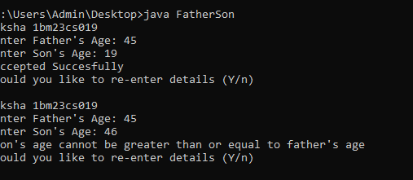

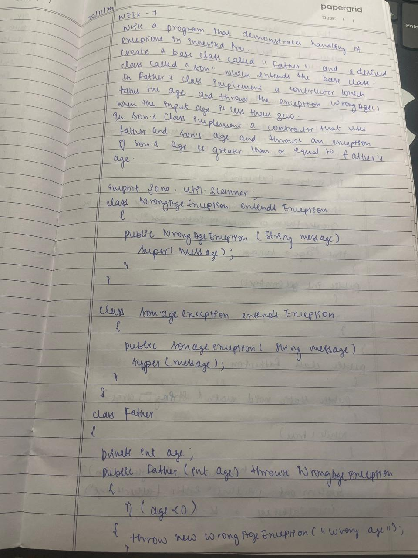

.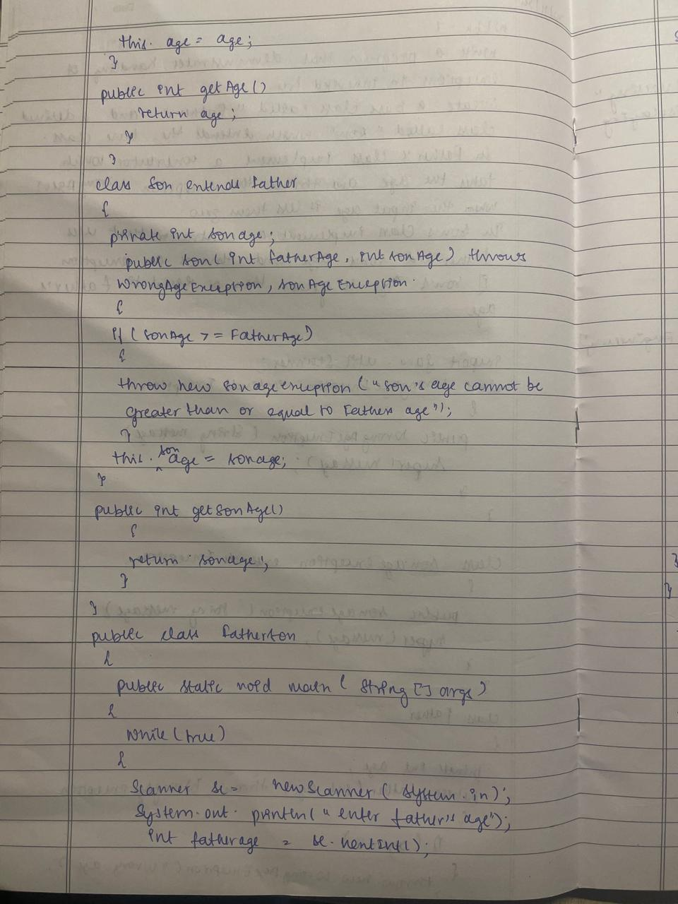

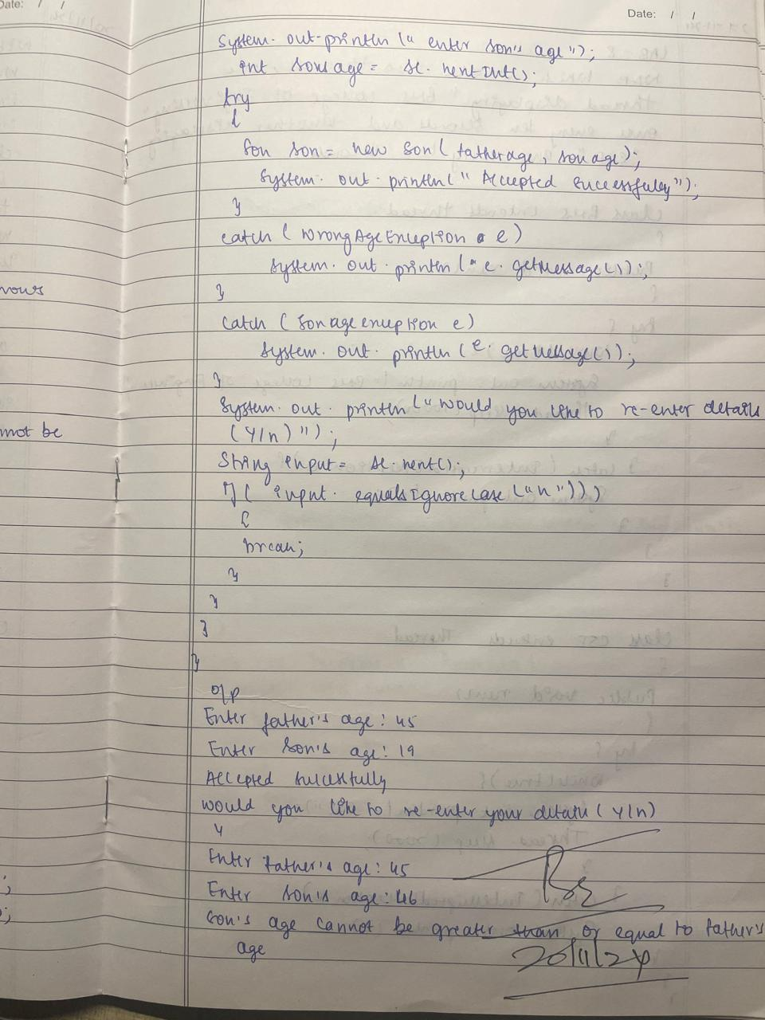

Code:

class Father {

private int age;

public Father(int age) throws WrongAgeException {

if (age < 0) {

throw new WrongAgeException("Wrong age");

}

this.age = age;

}

public int getAge() {

return age;

}

}

class Son extends Father {

private int sonAge;

public Son(int fatherAge, int sonAge) throws WrongAgeException, SonAgeException {

super(fatherAge);

if (sonAge >= fatherAge) {

throw new SonAgeException("Son's age cannot be greater than or equal to father's age");

}

this.sonAge = sonAge;

}

public int getSonAge() {

return sonAge;

}

}

public class FatherSon{

public static void main(String[] args) {

while(true){

Scanner sc = new Scanner(System.in);

System.out.println("aksha 1bm23cs019");

System.out.print("Enter Father's Age: ");

int fatherAge = sc.nextInt();

System.out.print("Enter Son's Age: ");

int sonAge = sc.nextInt();

try {

Son son = new Son(fatherAge, sonAge);

System.out.println("Accepted Succesfully");

}

catch (WrongAgeException e) {

System.out.println(e.getMessage());

}

catch (SonAgeException e) {

System.out.println(e.getMessage());

}

System.out.println("Would you like to re-enter details (Y/n)");

String input = sc.next();

if (input.equalsIgnoreCase("n")) {

break;

}

}

}

Program 8:

Write a program which creates two threads, one thread displaying “BMS College of Engineering”

once every ten seconds and another displaying “CSE” once

every two seconds.

Algorithm:

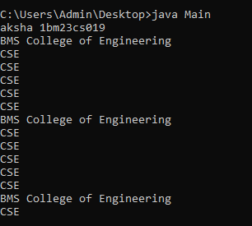

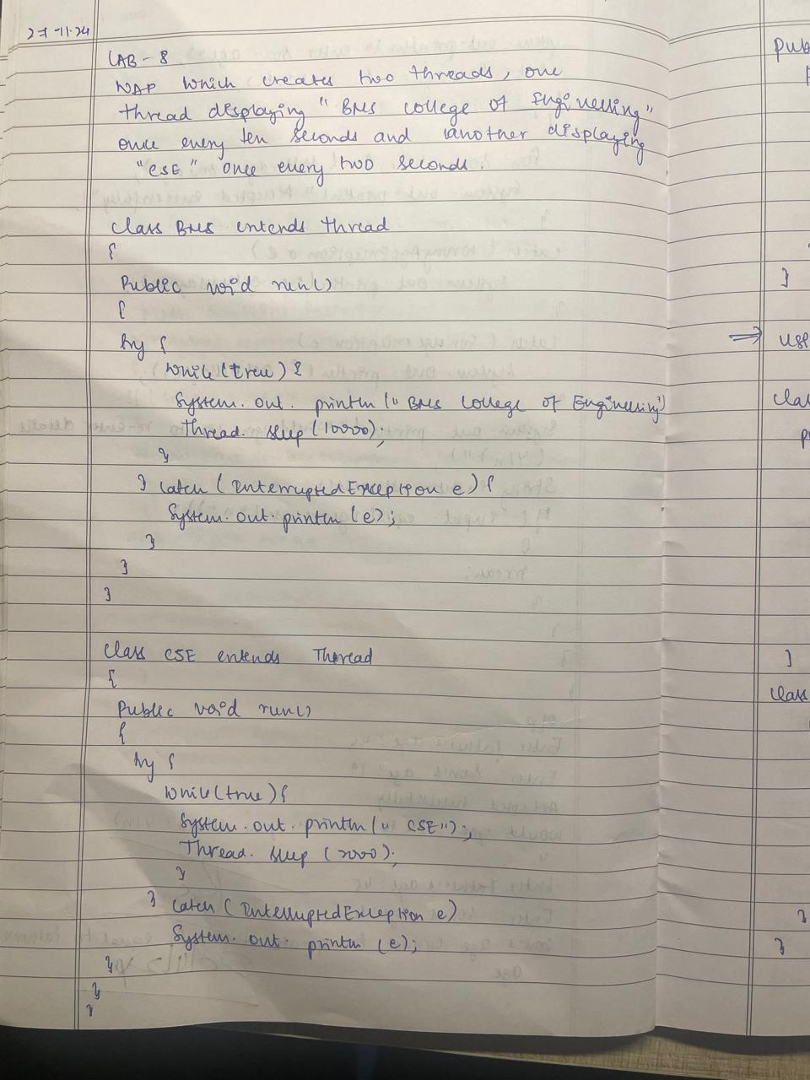

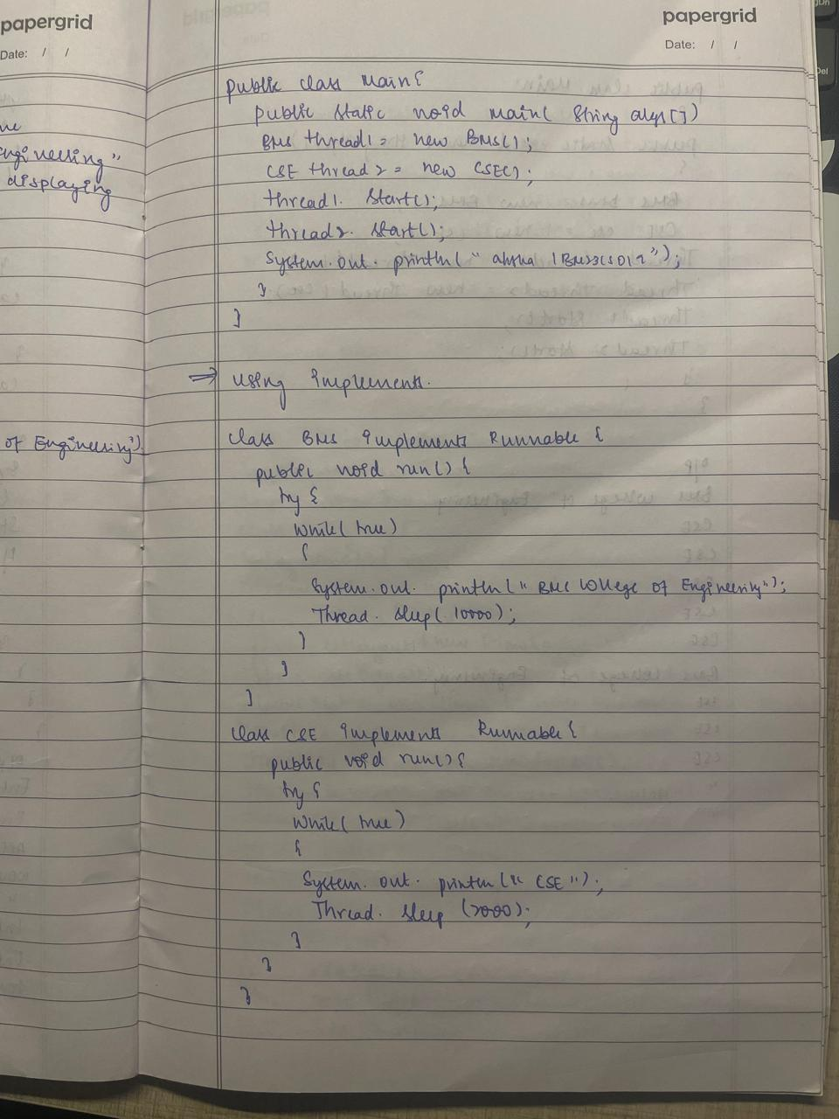

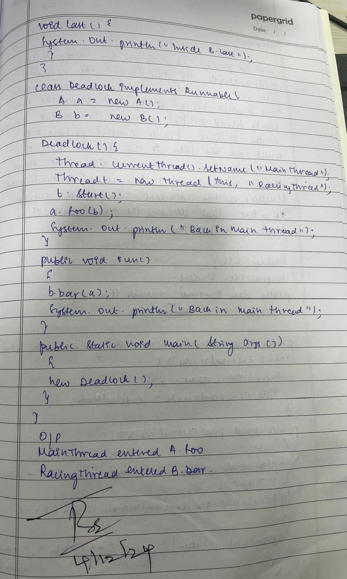

code:

class BMS extends Thread {

public void run() {

try {

while (true) {

System.out.println("BMS College of Engineering");

Thread.sleep(10000);

}

} catch (InterruptedException e) {

System.out.println(e);

}

}

}

class CSE extends Thread {

public void run() {

try {

while (true) {

System.out.println("CSE");

Thread.sleep(2000);

}

} catch (InterruptedException e) {

System.out.println(e);

}

}

}

public class Main {

public static void main(String[] args) {

// Creating two threads

BMS thread1 = new BMS();

CSE thread2 = new CSE();

// Starting the threads

thread1.start();

thread2.start();

System.out.println("aksha 1bm23cs019");

}

}

class BMS implements Runnable {

public void run() {

try {

while (true) {

System.out.println("BMS College of Engineering");

Thread.sleep(10000); // Sleep for 10 seconds

}

} catch (InterruptedException e) {

System.out.println(e);

}

}

}

class CSE implements Runnable {

public void run() {

try {

while (true) {

System.out.println("CSE");

Thread.sleep(2000); // Sleep for 2 seconds

}

} catch (InterruptedException e) {

System.out.println(e);

}

}

}

public class Demo {

public static void main(String[] args) {

// Create instances of Runnable classes

BMS bms = new BMS();

CSE cse = new CSE();

// Create Thread objects and pass the Runnable instances to them

Thread thread1 = new Thread(bms);

Thread thread2 = new Thread(cse);

// Start the threads

thread1.start();

thread2.start();

System.out.println("aksha 1bm23cs019");

}

}

Program 9:

Write a program that creates a user interface to perform integer divisions.

The user enters two numbers in the text fields, Num1 and Num2. The division of

Num1 and Num2 is displayed in the Result field when the Divide button is clicked.

If Num1 or Num2 were not an integer, the program would throw a

NumberFormatException. If Num2 were Zero, the program would throw an

Arithmetic Exception Display the exception in a message dialog box.

Algorithm:

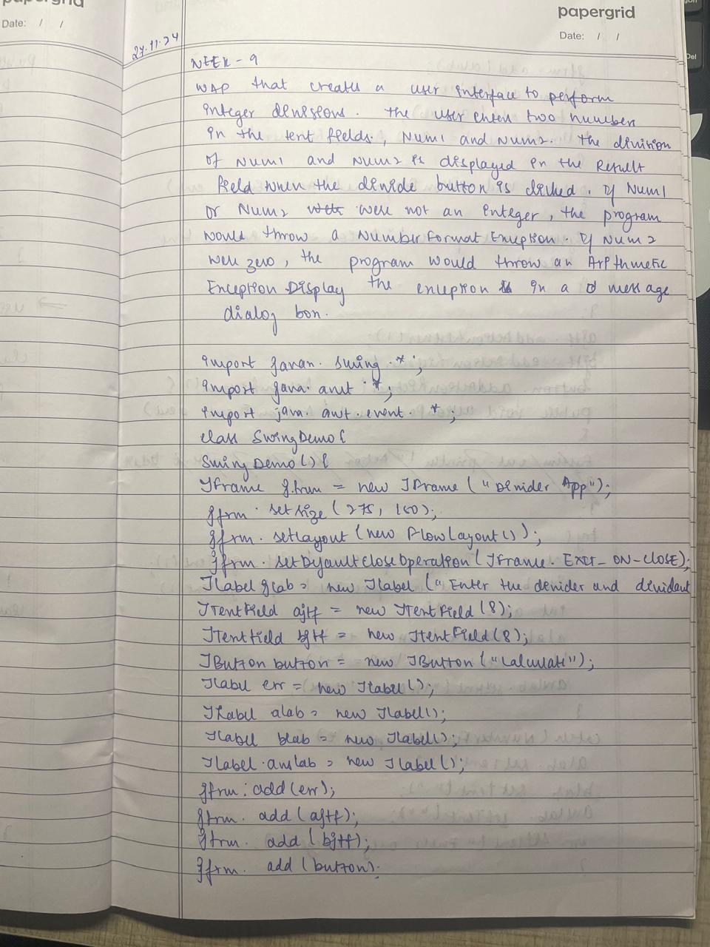

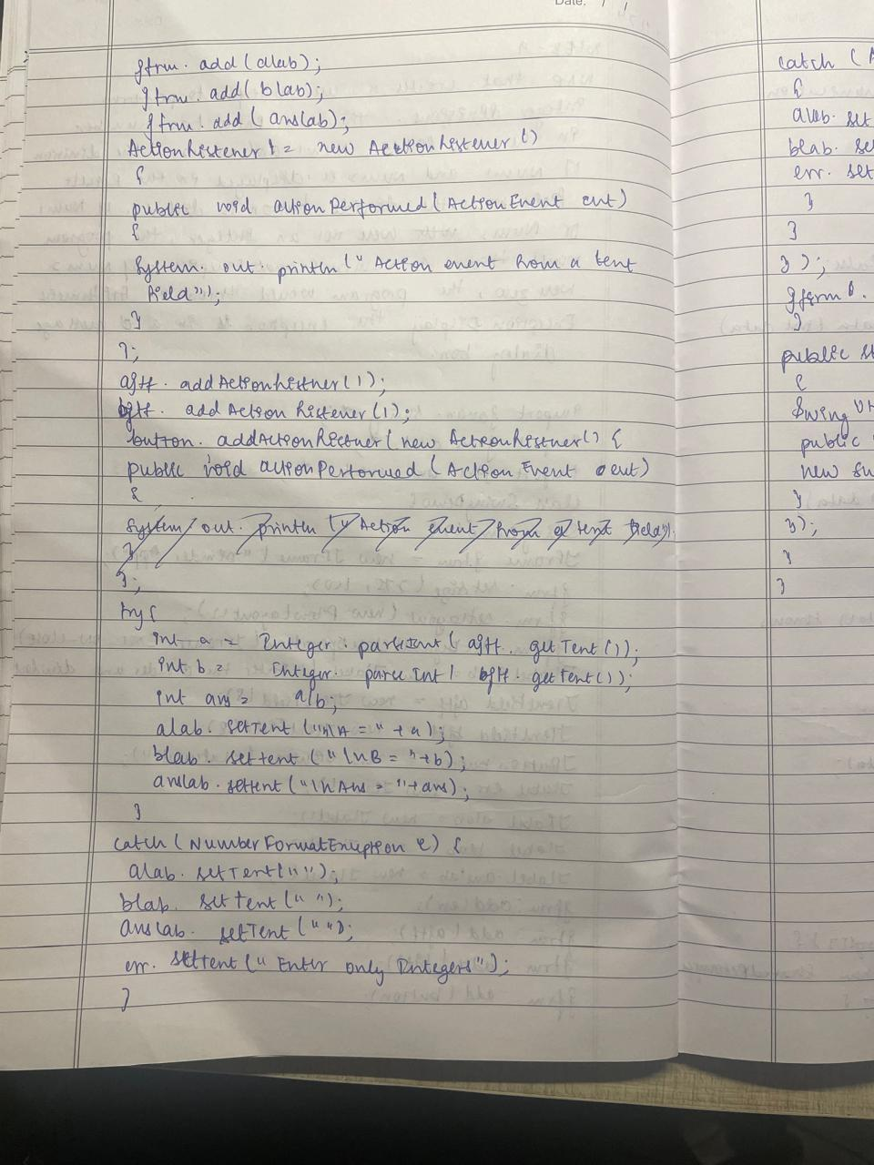

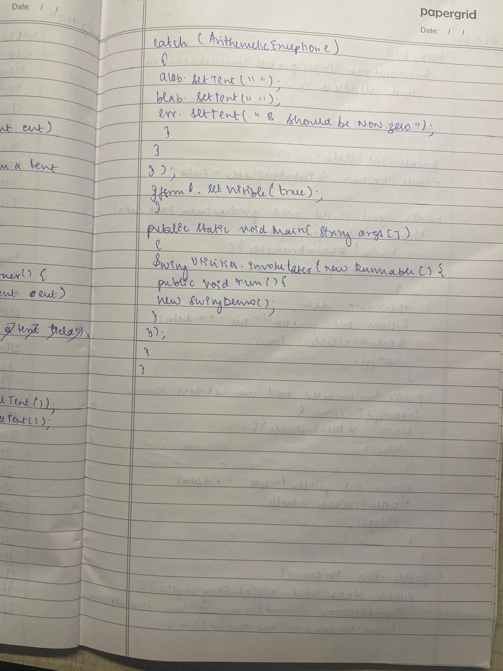

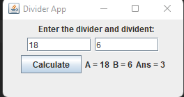

Code:

import javax.swing.*;

import java.awt.*;

import java.awt.event.*;

class SwingDemo{

SwingDemo(){

// create jframe container

JFrame jfrm = new JFrame("Divider App");

jfrm.setSize(275, 150);

jfrm.setLayout(new FlowLayout());

// to terminate on close

jfrm.setDefaultCloseOperation(JFrame.EXIT_ON_CLOSE);

// text label

JLabel jlab = new JLabel("Enter the divider and divident:");

// add text field for both numbers

JTextField ajtf = new JTextField(8);

JTextField bjtf = new JTextField(8);

// calc button

JButton button = new JButton("Calculate");

// labels

JLabel err = new JLabel();

JLabel alab = new JLabel();

JLabel blab = new JLabel();

JLabel anslab = new JLabel();

// add in order :)

jfrm.add(err); // to display error bois

jfrm.add(jlab);

jfrm.add(ajtf);

jfrm.add(bjtf);

jfrm.add(button);

jfrm.add(alab);

jfrm.add(blab);

jfrm.add(anslab);

ActionListener l = new ActionListener() {

public void actionPerformed(ActionEvent evt) {

System.out.println("Action event from a text field");

}

};

ajtf.addActionListener(l);

bjtf.addActionListener(l);

button.addActionListener(new ActionListener() {

public void actionPerformed(ActionEvent evt) {

try{

int a = Integer.parseInt(ajtf.getText());

int b = Integer.parseInt(bjtf.getText());

int ans = a/b;

alab.setText("\nA = " + a);

blab.setText("\nB = " + b);

anslab.setText("\nAns = "+ ans);

}

catch(NumberFormatException e){

alab.setText("");

blab.setText("");

anslab.setText("");

err.setText("Enter Only Integers!");

}

catch(ArithmeticException e){

alab.setText("");

blab.setText("");

anslab.setText("");

err.setText("B should be NON zero!");

}

}

});

// display frame

jfrm.setVisible(true);

}

public static void main(String args[]){

// create frame on event dispatching thread

SwingUtilities.invokeLater(new Runnable(){

public void run(){

new SwingDemo();

}

});

}

}

Program 10:

Open Ended Exercise

Demonstrate Inter process Communication and deadlock

Algorithm:

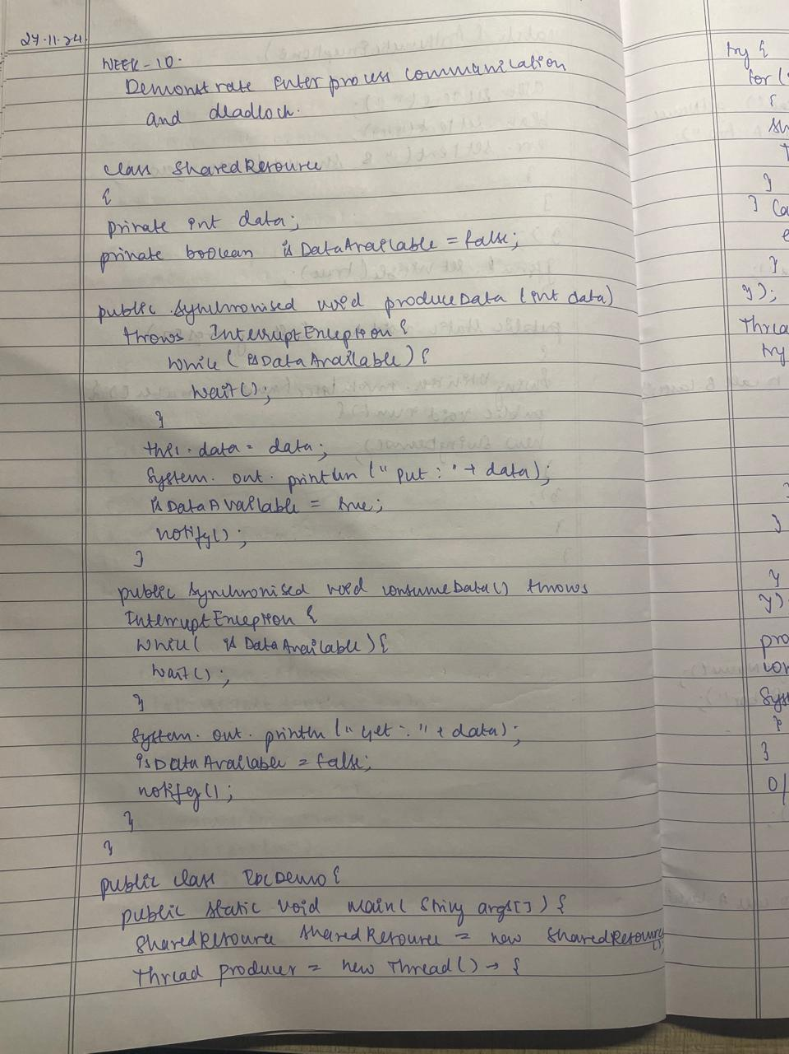

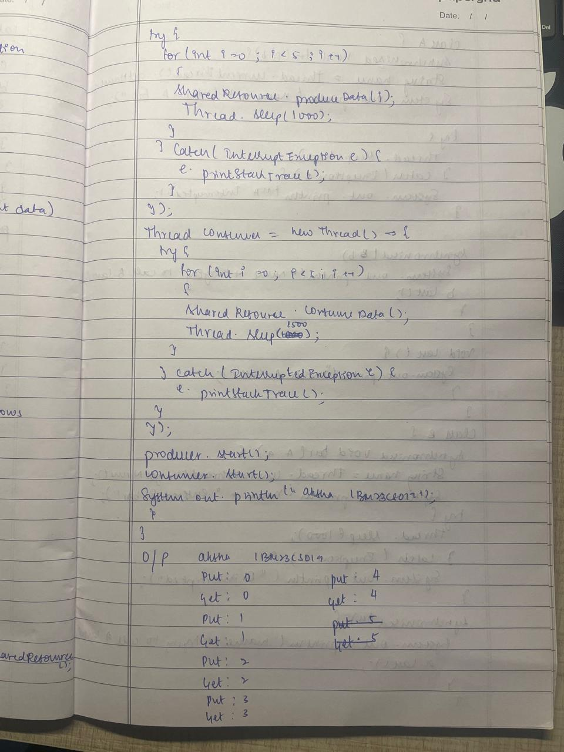

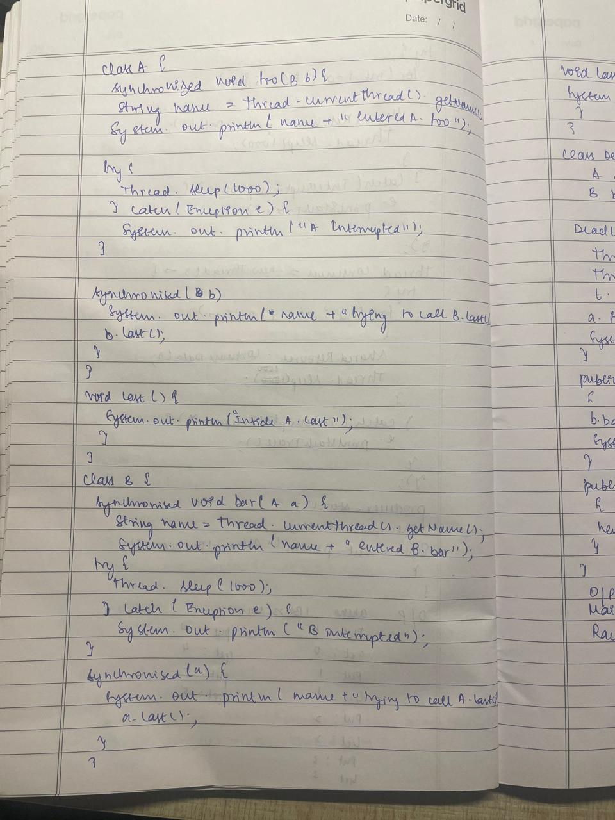

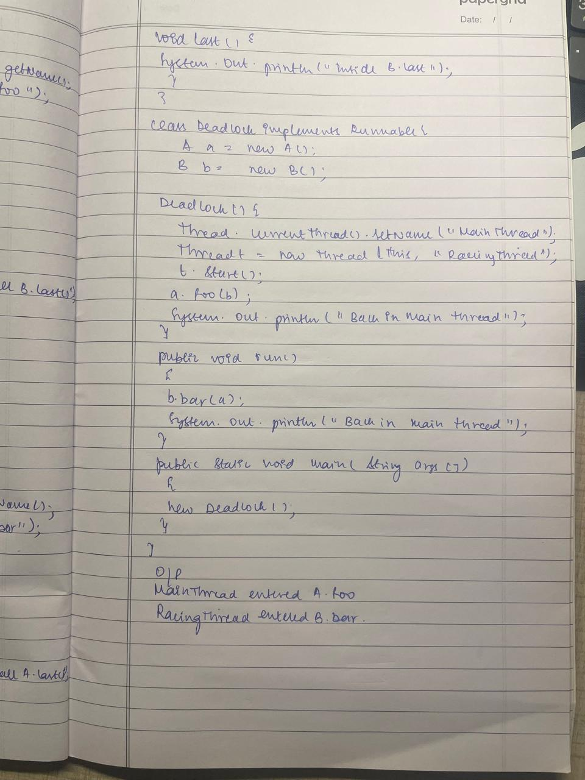

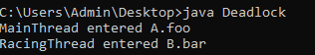

code:

IPC

class SharedResource {

private int data;

private boolean isDataAvailable = false;

// Producer thread

public synchronized void produceData(int data) throws InterruptedException {

while (isDataAvailable) {

wait(); // Wait if data is already available

}

this.data = data;

System.out.println("Put: " + data);

isDataAvailable = true;

notify(); // Notify consumer thread that data is available

}

// Consumer thread

public synchronized void consumeData() throws InterruptedException {

while (!isDataAvailable) {

wait(); // Wait if no data is available

}

System.out.println("Get: " + data);

isDataAvailable = false;

notify(); // Notify producer thread that data is consumed

}

}

public class IPCDemo {

public static void main(String[] args) {

SharedResource sharedResource = new SharedResource();

// Producer thread

Thread producer = new Thread(() -> {

try {

for (int i = 0; i < 5; i++) {

sharedResource.produceData(i);

Thread.sleep(1000); // Simulate some time taken to produce

}

} catch (InterruptedException e) {

e.printStackTrace();

}

});

// Consumer thread

Thread consumer = new Thread(() -> {

try {

for (int i = 0; i < 5; i++) {

sharedResource.consumeData();

Thread.sleep(1500); // Simulate some time taken to consume

}

} catch (InterruptedException e) {

e.printStackTrace();

}

});

producer.start();

consumer.start();

System.out.println("aksha 1bm23cs019");

}

}

DEADLOCK

class A {

synchronized void foo(B b) {

String name = Thread.currentThread().getName();

System.out.println(name + " entered A.foo");

try {

Thread.sleep(1000);

} catch (Exception e) {

System.out.println("A Interrupted");

}

// Now acquire the lock on B after the lock on A

synchronized (b) {

System.out.println(name + " trying to call B.last()");

b.last();

}

}

void last() {

System.out.println("Inside A.last");

}

}

class B {

synchronized void bar(A a) {

String name = Thread.currentThread().getName();

System.out.println(name + " entered B.bar");

try {

Thread.sleep(1000);

} catch (Exception e) {

System.out.println("B Interrupted");

}

// Now acquire the lock on A after the lock on B

synchronized (a) {

System.out.println(name + " trying to call A.last()");

a.last();

}

}

void last() {

System.out.println("Inside B.last");

}

}

class Deadlock implements Runnable {

A a = new A();

B b = new B();

Deadlock() {

Thread.currentThread().setName("MainThread");

Thread t = new Thread(this, "RacingThread");

t.start();

a.foo(b); // get lock on a in this thread

System.out.println("Back in main thread");

}

public void run() {

b.bar(a); // get lock on b in other thread

System.out.println("Back in other thread");

}

public static void main(String args[]) {

new Deadlock();

}

}